A Major Project Report
on

DEPRESSION AND QUALITY OF LIFE INVESTIGATION

Submitted in partial fulfillment of the requirement for
The award of degree of

BACHELOR OF TECHNOLOGY
in

COMPUTER SCIENCE & ENGINEERING 2020-2024

Submitted By
S.V.B.N.S.Ravali | 19311A05M9
K.Pooja Reddy | 19311A05K0
P.Anushka Reddy | 19311A05K8

Under the Guidance of


Dr. T. Vijaya Saradhi Professor

Department of Computer Science & Engineering
SREENIDHI INSTITUTE OF SCIENCE AND TECHNOLOGY

(AUTONOMOUS)
Yamnampet (V), Ghatkesar (M), Hyderabad – 501301, T.S.

AY 2023-2024

Sreenidhi Institute of Science and Technology


Department of Computer Science and Engineering

CERTIFICATE
This is to certify that this Major Project report on “Depression And Quality Of Life Investigation”, submitted by S.V.B.N.S.Ravali (19311A05M9) , K. Pooja Reddy (19311A05K0) , P.Anushka Reddy (19311A05K8) in the year 2024 in the partial fulfillment of the academic requirements of Jawaharlal Nehru Technological University for the award of the degree of Bachelor of Technology in Computer Science and Engineering, is a bonafide work that has been carried out by them as a part of their Major Project during Fourth Year Second Semester, under our guidance. This report has not been submitted to any other Institute or university for the award of any degree.

Internal guide | Project Coordinator | Head of the Department
Dr. T. Vijaya Saradhi | Mrs. B.Vasundhara Devi | Dr. K. Shirisha
Professor | Assistant Professor | Professor
Department of CSE | Department of CSE | Department of CSE

Signature of the External Examiner
Date:-

DECLARATION

We S.V.B.N.S.Ravali (19311A05M9) , K. Pooja Reddy (19311A05K0) ,

P.Anushka Reddy (19311A05K8) students of SREENIDHI INSTITUTE OF SCIENCE AND TECHNOLOGY, YAMNAMPET, GHATKESAR, studying IV
year II semester, COMPUTER SCIENCE AND ENGINEERING solemnly declare that the Major Project work, titled “Depression And Quality Of Life Investigation” is submitted to SREENIDHI INSTITUTE OF SCIENCE AND TECHNOLOGY for partial fulfillment for the award of degree of Bachelor of technology in COMPUTER SCIENCE AND ENGINEERING.
It is declared to the best of our knowledge that the work reported does not form part of any dissertation submitted to any other University or Institute for award of any degree.
S.V.B.N.S.Ravali | 19311A05M9
K.Pooja Reddy | 19311A05K0
P.Anushka Reddy | 19311A05K8

ACKNOWLEDGEMENT

We would like to express our gratitude to all the people behind the screen who helped us to transform an idea into a real application.
We would like to thank our internal guide Dr. T. Vijaya Saradhi and our Coordinator Mrs. B.Vasundhara Devi for Major Project for their technical guidance, constant guidelines, encouragement and support in carrying out Major project on time at college.

We profoundly thank Dr. K. Shirisha, Head of the Department of Computer Science & Engineering who has been an excellent guide and also a great source of inspiration to our work.
We would like to express our heart-felt gratitude to our parents without whom we would not have been privileged to achieve and fulfill our dreams. We are grateful to our principal, DR. T. Ch. Siva Reddy, who most ably runs the institution and has had the major hand in enabling us to do our project.
The satisfaction and euphoria that accompany the successful completion of the task would be great but incomplete without the mention of the people who made it possible with their constant guidance and encouragement crowns all the efforts with success. In this context, We would like to thank all the other staff members, both teaching and non-teaching, who have extended their timely help and eased our task.

S.V.B.N.S.Ravali | 19311A05M9
K.Pooja Reddy | 19311A05K0
P.Anushka Reddy | 19311A05K8

ABSTRACT

The healthcare industry is currently undergoing a significant metamorphosis, primarily propelled by the emergence of sophisticated technological innovations. The identification of causal factors that may be associated with the onset of depression has the potential to provide a roadmap for future investigations and therapeutic interventions. The discernible escalation in occurrences of depression on a global scale underscores the imperative for according priority to public health measures. This study presents a comprehensive methodology for the utilization of machine learning methods for the purpose of processing and analysing heterogeneous data. The primary goal of this structure is to acquire a comprehensive comprehension of the interrelation between diverse facets associated with quality of life and the occurrence of depression.

i

LIST OF FIGURES
S.NO | Figure No. | Title of Figure | Page No
1 | 1 | System Architecture | 37
2 | 2 | Data Flow Diagram | 38
3 | 3 | Class Diagram | 39
4 | 4 | Use Case Diagram | 40
5 | 5 | Sequence Diagram | 41
6 | 6 | Activity Diagram | 42
7 | 7 | Dashboard | 66
8 | 8 | Registration Form | 66
9 | 9 | Login Form | 67
10 | 10 | Out Come Graph | 67
11 | 11 | Form Filling-I | 68
12 | 12 | Form Filling-II | 68
13 | 13 | Result Page | 69

ii

LISTOFTABLES
S.NO | Table No. | Title of Table | PageNo
1 | 1 | Test Cases | 74

iii

INDEX

 | Page No
List of Figures | i
List of Tables | ii
1. INTRODUCTION
1.1 Project Introduction | 1
1.2 Scope | 2
1.3 Project Overview | 3
1.4 Objectives | 4
2. LITERATURE SURVEY
2.1 Existing System | 5
2.1.1 Disadvantages Of Existing System | 6
2.2 Proposed System | 6
2.2.1 Advantages Of Proposed System | 7
3. SYSTEM ANALYSIS
3.1 Functional Requirements | 9
3.1.1 Data Collection | 10
3.1.2 Data Preprocessing | 14
3.1.3 Training and Testing | 18
3.1.4 Modeling | 21
3.1.5 Predicting | 24
3.2 Performance Requirements | 26
3.3 Software Requirements | 27
3.3.1 Python Idle | 28
3.3.2 Anaconda | 29
3.3.3Jupyter | 30
3.3.4 Google Colab | 32
3.4 Hardware Requirements | 34
3.4.1 Processor: (Pentium Iv Or Higher) | 34
3.4.2 Ram: (256 Mb) | 35
3.4.3 Space On Hard Disk: (Minimum 512mb) | 35
3.5 Feasibility study (Technical/Economical/Operational) | 35
3.5.1 Economical Feasibility | 35
3.5.2 Technical Feasibility | 36
3.5.3 Social Feasibility | 36
4. SYSTEM DESIGN
4.1 System Architecture | 37
4.2 Modules of the Project | 38
4.3 Data Flow Diagrams | 39
4.4 UML Diagrams
4.4.1 Class Diagram | 39
4.4.2 Use Case Diagram | 40
4.4.3 Sequence Diagram | 41

iii

4.4.4 Activity Diagram | 42
5. IMPLEMENTATION AND RESUTS
5.1 Language / Technology Used | 48
5.1.1 Python | 48
5.1.2 Advantages Of Python | 49
5.1.3 Advantages Of Python Over Other Languages | 57
5.1.4 Disadvantages of Python | 60
5.2 Sample Code | 64
5.3 Results (Accuracy) / Output Screens | 66
6. TESTING
6.1 Types of Testing | 70
6.1.1 Unit Testing | 70
6.1.2 Data Flow Testing | 71
6.1.3 Integration Testing | 71
6.1.4 Big Bang Integration Testing | 72
6.1.5 User Interface Testing | 73
6.2 Test Cases | 74
7. CONCLUSION | 75
8. FUTURE SCOPE | 76
9. BIBLIOGRAPHY | 78
APPENDIX-A : | 79-87
PLAGIARISM REPORT | 88-92
PAPER PUBLICATION | 93-101
ABSTRACT | 102
PROJECT CORRELATION WITH PO’s AND PSO’s | 103
NATURE OF THE PROJECT | 104
DOMAIN OF THE PROJECT | 105

v

INTRODUCTION

INTRODUCTION

PROJECT INTRODUCTION

The healthcare domain poses a substantial hurdle at the global level, irrespective of the socioeconomic circumstances in a particular nation. The enhancement of intelligent, skilful, and reinforced healthcare systems has emerged as a significant global concern with the overarching objective of improving the quality of life. The initial investigation into human behaviour has stimulated the curiosity of scholars from various fields of inquiry to undertake research in the realms of psychology and neuroscience.

By contrast, a comparable phenomenon is evident in the rapidly evolving realm of inquiry pertaining to the disciplines of computer science and artificial intelligence.The persistent predicament faced by medical practitioners and healthcare institutions in detecting psychological health concerns among patients, particularly those in the younger age bracket, continues to be an enduring subject of contemplation in scholarly discourse.

Recent progress has convincingly demonstrated the efficacy of machine learning and deep learning in the identification of psychological disorders and differentiation of their corresponding impacts on an individual's daily behaviours and cognitive processes. The metamorphosis of an individual's psychological well-being constitutes a crucial juncture in their developmental path that is eagerly sought after by a vast array of individuals across the globe.

The recognition of the pervasive pervasiveness of anxiety and depression across a wide range of age cohorts has generated an appreciation for the crucial import assigned to these specific maladies. The quality of life (QoL) of an individual is significantly impacted by various factors, ultimately leading to a reduced ability for optimal decision-making.

As a result of the aforementioned phenomenon, there is a concomitant increase in the severity of psychological distress and an escalated likelihood of progressing towards the introspection or manifestation of suicidal ideation. Depression is a commonly acknowledged, multi-dimensional, and formidable mental health issue that extensively exacerbates the total disease burden in all medical domains. Post

the occurrence, a myriad of scholars and healthcare experts have shifted their research pursuits towards the examination of the depressive state. In future depression is expected to emerge as a significant contributor to mortality and morbidity rates, as predicted by projections put forth by the World Health Organization. After a successful implementation of a therapeutic intervention, the continuing and enduring expression of depressive symptoms can substantially hinder an individual's cognitive and functional capacities.

SCOPE

In recent years, the field of health sciences has seen significant advancements in both the analytical methods used to identify and treat illnesses and the technology used to support these efforts. However, these advancements did not happen overnight. Instead, they are the result of a long history of scientific inquiry and experimentation that has helped us better understand the human body and the diseases that affect it.

One of the earliest known examples of scientific inquiry into health and illness can be traced back to ancient civilizations such as Egypt, China, and India. These early cultures developed their own methods of diagnosing and treating illnesses, including the use of herbal remedies, acupuncture, and surgery. In the modern era, the development of scientific methods and technology has led to significant advancements in the field of health sciences.

In the 19th century, for example, the use of microscopes allowed scientists to observe microorganisms and better understand the causes of infectious diseases. Later, the discovery of X-rays and other imaging technologies revolutionized the field of diagnostics, allowing doctors to see inside the human body and identify a wide range of health issues.

Today, we continue to see rapid advancements in health sciences, driven in large part by the proliferation of big data and machine learning technology. These tools enable us to analyze massive amounts of data from a variety of sources, including medical records, genetic sequencing data, and health sensor data.

With this information, we can better understand the underlying causes of illnesses, predict the likelihood of disease in individuals, and develop more

effective treatments. Ultimately, the ability to use big data and machine learning to analyze health information has the potential to transform the way we conceptualize care in health sciences.

By providing a more comprehensive understanding of the factors that contribute to health and illness, we can develop more personalized and effective treatment plans that can help individuals lead longer, healthier lives.

PROJECT OVERVIEW

The field of mental health is an important and complex area of study that has significant implications for individuals and society as a whole. While traditional approaches to mental health research and treatment have yielded some important insights, recent advancements in machine learning (ML) and big data analytics have the potential to revolutionize the field.

The purpose of this study is to synthesize the existing literature on ML and big data applications for mental health, with a specific focus on depression and anxiety in relation to the quality of life for cancer patients receiving palliative care. By conducting a scoping review of the relevant research, we aim to quickly map the field of ML in mental health, identifying key themes, research gaps, and areas for future investigation.

To achieve this goal, we utilized a scoping review methodology, which involves a systematic and comprehensive search of multiple research databases to identify relevant literature. In this case, we examined eight different health and information technology research databases to find papers that addressed the topic of ML in mental health, specifically as it relates to depression and anxiety in cancer patients receiving palliative care.

By synthesizing the literature on this topic, we hope to gain a deeper understanding of how ML and big data can be used to improve mental health outcomes for individuals facing serious illnesses such as cancer. Our findings may have important implications for the development of more effective and personalized treatments for depression and anxiety, ultimately improving the quality of life for patients and their families.

OBJECTIVES

The use of persuasive technology in enhancing well-being is a promising area of study that has the potential to provide several advantages in alleviating mental health issues. To achieve this objective, a multidisciplinary and interdisciplinary approach is required, which aims to alter behaviour or attitudes without resorting to trickery or compulsion.

The major goal of this study is to explore the potential benefits of persuasive technology in mental health care, while also providing a brief review of the topic. In addition to this, the paper also aims to provide general, technical, and critical perspectives on the deployment of such systems, as well as their impact in terms of prospective advantages and disadvantages.

Through this study, we hope to demonstrate that persuasive technology can support current approaches to mental health care, while also addressing issues of access and consequence inequities. By using persuasive technology to promote positive behaviour and attitudes, we can potentially improve mental health outcomes for a wide range of individuals, including those who may not have access to traditional forms of mental health care.

However, it is important to recognize that the deployment of persuasive technology also has its limitations and potential downsides. Therefore, our study also aims to identify and critically evaluate these factors, in order to gain a more comprehensive understanding of the potential impact of persuasive technology in mental health care.

In summary, this study aims to explore the potential of persuasive technology in enhancing mental health care, while also providing a critical evaluation of its impact and limitations.

LITERATURE SURVEY

LITERATURE SURVEY

EXISTING SYSTEM

The existing system highlights the effectiveness and robustness of Support Vector Machine (SVM) as a classification algorithm used for various real-world applications. The performance and efficiency of SVM are mainly dependent on its parameters, which can affect the recognition rate. Compared to other classification methods, SVM has a higher rate of recognition. The concept of SVM was introduced by Vapnik at Bell Laboratories.

Although originally developed as binary classifiers, some proposed extensions can handle multiclass classification cases. These extensions apply additional parameters and constraints to the optimization problem to manage the separation of different classes.

Common methods of applying SVMs to multiclass classification problems often involve breaking down the problem into several two-class problems. In recent years, SVM has become a research hotspot in machine learning due to its excellent learning efficiency.

However, the existing system also implies that SVM has some limitations. For example, SVM may not be the best choice for datasets with a large number of features, as it can lead to long training times and overfitting. Additionally, SVM requires careful selection of parameters to achieve optimal performance, which can be challenging and time-consuming.

To address these limitations, researchers are exploring various methods to improve SVM's performance and efficiency, such as using feature selection techniques, optimizing parameter selection methods, and developing new variants of SVM. Overall, SVM remains a popular choice for classification tasks due to its robustness and efficiency, and it is expected that further advancements in SVM will continue to enhance its capabilities in handling complex datasets.

DISADVANTAGES OF EXISTING SYSTEM:

The existing system has some notable disadvantages that limit its effectiveness. Firstly, the model's efficiency is relatively low, meaning that it may not accurately capture all the important factors and nuances associated with depression. As a result, the model's predictions and recommendations may not be entirely reliable or effective.

Secondly, the identification of factors that contribute to depression is a crucial step towards developing new experiments and treatments. Unfortunately, the existing system may not be able to identify all the relevant factors that are responsible for causing depression, which limits the potential for new discoveries and advancements in the field.

Finally, depression is an increasingly concerning health issue worldwide, and as such, it requires effective and reliable solutions. The existing system's limitations may hinder progress in the development of effective treatments, which could have severe consequences for individuals and communities affected by depression.

Therefore, it is essential to address the shortcomings of the current system and develop more advanced and efficient models that can accurately capture the complexities of depression and provide reliable solutions.

PROPOSED SYSTEM

To address the challenges of studying heterogeneous data and understanding the correlation between aspects of quality of life and depression, the proposed system utilizes machine learning techniques. The experimental study is divided into two primary components.

In the first section, a data consolidation procedure is introduced to establish relationships between data elements and identify them uniquely using the Secure Hash Algorithm concept. By using hashing to index and locate data elements, the consolidation approach creates a comprehensive base for the formulation and validation of research hypotheses.

The second part of the proposed system involves a model that employs both unsupervised and supervised machine learning techniques. The consolidation approach helps to generate a foundation for the model, which then utilizes the Self-Organizing Map (SOM) algorithm to create eight clusters of data points.

These clusters are then used to validate the performance of the posterior probability multi-class Support Vector Machine (SVM) in classifying depression cases.By utilizing both unsupervised and supervised machine learning techniques, the proposed system can identify previously unknown relationships between quality of life aspects and depression.

The SOM algorithm allows for the discovery of patterns and relationships within the data, while the multi-class SVM classification helps to validate the findings.This approach could significantly improve the accuracy of depression diagnoses and treatment recommendations, leading to better outcomes for individuals and communities affected by depression.

ADVANTAGES OF PROPOSED SYSTEM

The proposed system has several advantages over existing models, which can lead to improved classification performance and accuracy.

Firstly, the proposed model is designed to specifically address the limitations of existing models, and its unique approach to data consolidation and machine learning techniques provides a more comprehensive and accurate representation of the relationship between quality of life aspects and depression.

The results of the experimental study validate the effectiveness of the proposed model, as it was able to achieve high classification accuracy. This indicates that the proposed system can reliably and accurately classify depression cases, allowing for more effective treatment recommendations and improved outcomes for individuals and communities affected by depression.

Additionally, the proposed model's ability to provide more accurate diagnoses could lead to earlier intervention and treatment, reducing the likelihood of depression becoming a chronic condition. This, in turn, could reduce the overall burden of depression on healthcare systems and society as a whole.

Overall, the proposed system's ability to improve classification performance and accuracy, coupled with its potential to reduce the burden of depression on healthcare systems, makes it a valuable tool for addressing the challenges associated with depression diagnosis and treatment.

SYSTEM ANALYSIS

SYSTEM ANALYSIS

FUNCTIONAL REQUIREMENTS:

Functional requirements, alongside overall description documents, are deemed essential in delineating the extent of a given project. The aforementioned documents encompass diverse constituents that necessitate contemplation whilst devising a novel commodity or structure.

The operating system and operating environment constitute fundamental components, encompassing the hardware and software requirements indispensably indispensable for the effective functioning of the product. A critical element that warrants consideration pertains to the product perspective and its distinctive attributes.

This process encompasses delineating the targeted recipients of the product, the precise characteristics that are requisite for inclusion, and the overall operational capacity of the product. Furthermore, it is imperative to delineate the graphics specifications, encompassing the architectural arrangement, conception, and sensory constituents that will be assimilated into the artefact. Design limitations constitute an essential aspect of the functional requirements.

This pertains to the limitations and boundaries that require contemplation during the advancement process, including fiscal or temporal limitations. The final step in the product development process involves the establishment of user documentation, a crucial component that offers comprehensive details and resources necessary for users to acquire a complete understanding of the product's optimal use.

Furthermore, the judicious application of stipulated prerequisites and implementation constraints is pivotal in delineating a rudimentary framework of the project, highlighting its antecedents and shortcomings, and devising measures to mitigate them.

The discernment of these assets and liabilities aids in ascertaining the viability of the project and offers a potential avenue for the enhancement of the commodity in advance of its release. In brief, the inclusion of functional requirements and a comprehensive overview document are essential constituents in the process of devising a novel product or system. This set of documents guarantees that all requisite components are thoroughly examined and assimilated into the project, culminating in a prosperous and operational end-result.

DATA COLLECTION

The acquisition of information or data from numerous sources for the purpose of analysis, research, or decision-making is referred to as data collection. In a multitude of domains, encompassing scientific inquiry, market evaluation, and social investigations, among others, a pivotal phase is evident. The precision and dependability of accumulated information assume a crucial function in the exactness and authenticity of consequent evaluations and conclusions.The following discourse provides a comprehensive elucidation of the procedure employed in garnering data:

The given text is not available for rewriting. Please provide the required text to be rewritten. The initial step in research endeavors involves the definitive articulation of the research objective, wherein the primary aim of the data collection is precisely elucidated. It is imperative to identify the precise research queries or aims that necessitate attention.

The given text cannot be rewritten as there is no text provided. Please provide the necessary information or context to assist you better. The initial step in conducting research is to ascertain the data requirements necessary for attaining the research objective. This entails identifying the particular types of data that are needed to effectively address the research aims. This encompasses the identification of pertinent variables, measurements, and attributes that necessitate collection.

Thus, it is crucial to identify the particular sources that will be utilized in data collection. The selection of data sources is contingent upon the categorical scope

of the research. The methodologies employed may encompass a range of instruments, such as surveys, questionnaires, interviews, observations, established databases, publicly available records, or digital resources.

It is noteworthy to mention that a comparison between the number of cervical vertebrae in giraffes and humans yields equivalent results. This particular biological feature is a topic worth exploring given its potential for elucidating variations and commonalities in the anatomies of disparate organisms. The selection of suitable data collection techniques is crucial to the achievement of research objectives and the identification of pertinent data sources.

Thus, it is imperative to carefully design data collection methods in order to collect relevant and accurate data. Numerous techniques are available for the collection of data, such as:Surveys and questionnaires are established tools utilized in research and data collection. They entail structured sets of questions that require responses from respondents. Surveys can be administered through different modes, such as in-person, mail, telephone, or online.

Interviews are a method of data collection that involves one-on-one or group interactions with participants for the direct gathering of information. Interviews may possess a structured format, characterized by adherence to predetermined questions, or an unstructured format, which permits free-flowing discourse.

Observations involve the systematic recording of naturally occurring behaviors or events. This approach is particularly valuable in disciplines such as anthropology or psychology.

The empirical approach involves the creation of precise and regulated settings to enable the manipulation of certain factors, with the primary objective of analyzing their impact on the subsequently observed results. Such methodology is commonly employed in experimental investigations. The aforementioned method is widely employed in scientific inquiry.

The practice of employing pre-existing data, including public datasets, historical records, or data gathered by prior inquiries, is commonly referred to as utilizing existing data. This has the potential to yield time and cost savings.

The process of collecting data from various online sources, including websites, social media platforms, and application programming interfaces (APIs), is known as online data collection. The utilization of web scraping or data mining methodologies may be enacted.

The task of developing data collection instruments, in the form of survey questionnaires, interview guides, or coding schemes for observations, should be undertaken if it is deemed relevant to the research inquiry. It is imperative that the instruments utilized for data collection are intricately designed and standardized, in order to guarantee uniformity and precision in the process.

Unfortunately, without the vigilance and cooperation of the local community, it is unlikely that any meaningful progress will be made in addressing the issue of crime and violence in our neighborhood. In order to effect change, everyone must take responsibility and work together towards a common goal.

It is recommended to conduct a pilot test of the data collection instruments prior to commencing the actual data collection in order to validate and refine the instruments. This process facilitates the identification of potential issues, ambiguities, or biases, thus enabling the implementation of necessary modifications.

There are many places where one can find information on a variety of topics. The internet is a particularly useful resource, offering a vast array of information at one's fingertips. However, it is important to be cautious when using internet sources, as not all of the information available online is accurate or reliable. One should always evaluate the credibility of the source before incorporating it into their research.

Additionally, it may be beneficial to consult print materials, such as books and academic journals, as these sources have undergone a rigorous editing and review

process to ensure their accuracy and validity. Execute Data Collection: Conduct the process of gathering data in accordance with the chosen methodologies. Effective guidance should be provided to participants or data collectors to guarantee consistent and accurate data collection.

Data validation and cleaning are important processes to ensure the accuracy, completeness, and consistency of the collected data after the completion of data collection. The identification and resolution of any potential errors, outliers, or missing values is necessary. The process of preparing the data for subsequent analysis involves the systematic cleansing, organizing, structuring and formatting of the data.

Data storage and security have a paramount importance in safeguarding the privacy and confidentiality of research participants. Accordingly, it is incumbent upon researchers to ensure that any collected data is stored in a highly secure manner to prevent unauthorized access or disclosure. It is imperative to adhere to the pertinent regulations pertaining to data protection as well as implement the best practices in this domain.

This study highlights the importance of rigorously documenting the data collection process, encompassing comprehensive accounts of the employed research methods, used instruments, possible limitations and biases, and pertinent information regarding the participants or data sources. This documentation ensures a high degree of transparency and promotes replication or verification of the research findings.

The collection of data is a crucial component in any undertaking that is reliant on data. The precision, pertinence, and dependability of accrued data exert a direct influence on the caliber and legitimacy of subsequent examinations and discoveries. Henceforth, it is crucial to engage in meticulous planning, meticulous attention to detail, and strict adherence to ethical principles during the entirety of the data gathering procedure.

DATA PREPROCESSING

The process of data preprocessing holds significant importance in the pipeline of data analysis and machine learning. The process entails converting unprocessed information into a structure that is appropriate for examination and instruction of predictive models. Data preprocessing pertains to the systematic and essential steps that involve the refinement, standardization, and categorization of raw data to enhance the quality and efficacy of subsequent analytical or modeling procedures.

Data cleaning, also known as data cleansing or data scrubbing, refers to the process of identifying and correcting or removing inaccurate, incomplete, or irrelevant data from a dataset. This process is necessary for ensuring the quality and integrity of the data, which is essential for accurate and reliable data analysis and decision-making.

Data cleaning involves a variety of techniques, such as data profiling, parsing, standardization, and matching, and may also involve the use of machine learning algorithms and other advanced tools for identifying and addressing data quality issues.The management of absent data is a crucial step in data analysis. It involves the identification and subsequent handling of any missing data points, which may necessitate the removal of incomplete records, imputation of the missing values, or the application of statistical techniques such as mean, median, or mode imputation.

The identification and treatment of outliers, defined as values that diverge significantly from the standard distribution of a given dataset, constitute an integral component of data analysis. The management of outliers can be accomplished by means of three possible methods which include their removal, transformation, or substitution with more suitable values.

Eliminating Redundancies: Distinguish and eliminate duplicate entries from the dataset, as they may distort analytical or modeling outcomes. There is a need for further investigation into the topic of online learning, as it has become increasingly prevalent in recent years. The potential benefits and drawbacks of

online learning should be thoroughly explored, as well as the effectiveness of online teaching methods. Additionally, the experiences and perspectives of both students and instructors involved in online learning should be studied to gain a comprehensive understanding of the topic.

It is important for academic research to inform and guide the development and implementation of online learning programs. The process of converting data from one format or structure to another, typically to enhance its usefulness or compatibility with a particular system or application, is referred to as data transformation.

In the context of data preprocessing, the utilization of feature scaling techniques is imperative to ensure that the influence of certain variables is not disproportionately strong. This is achieved by transforming numerical features onto a standardized scale which accounts for variations in magnitude within the data. Such an approach serves to mitigate potential bias and ensure the appropriate weighting of each feature in subsequent analysis.

Scaling techniques commonly employed include normalization, which involves scaling numerical values to lie between the values of 0 and 1, and standardization, whereby values are adjusted to obtain a zero mean and unit variance. The process of encoding categorical variables involves transforming them into numerical representations that can be comprehended by machine learning models. Various methodologies employed in this regard include one-hot encoding, label encoding, and binary encoding.

The treatment of skewness involves addressing skewed distributions in numerical features through the utilization of various transformations, including but not limited to logarithmic, square root, or Box-Cox transformations. These transformations aim to render the data more normally distributed.

Feature engineering involves the generation of novel features by either manipulating or extracting more significant information through mathematical operations from an existing set of attributes. This may encompass the amalgamation of attributes, the derivation of proportions or percentages, or the formulation of interactional terminologies.

This process involves a series of tasks, including data mapping, data transformation, and data loading, to enable smooth data exchange between systems. The aim of data integration is to create a comprehensive understanding of complex data structures across various platforms and enable effective decision- making. Achieving data integration requires the adoption of appropriate tools and technologies, such as ETL (Extract, Transform and Load) software, data warehousing and master data management, among others.

The application of data integration is increasingly critical for businesses and organizations seeking to leverage data-driven insights and improve operational efficiency. In order to ensure data compatibility, it may be necessary to merge or combine multiple datasets while maintaining consistency in data types and structures. One should seek to rectify any inconsistencies or disparities that may arise in the use of naming conventions, units of measurement, or data formats.

It is necessary to approach the subject of climate change with a sense of urgency, as it poses a significant threat to our planet and all its inhabitants. The evidence for human-induced climate change is overwhelming, and it is imperative that we take immediate action to mitigate its effects. This requires a coordinated effort from individuals, governments, and businesses, as well as investment in sustainable technologies and practices.

Failure to act decisively in the face of climate change will have disastrous consequences for our planet and future generations. Therefore, we must prioritize this issue and work towards long-term solutions. The process of reducing data to a more concise and manageable form is commonly referred to as "data reduction." This approach involves analyzing a large amount of data and identifying and extracting the most significant information, while discarding extraneous or inconsequential data. Data reduction is an important step in most research studies and is used to enhance data interpretation and analysis.

One approach to data analysis involves employing dimensionality reduction techniques, which aim to decrease the number of different characteristics or variables present within a given dataset while still preserving the most critical

pieces of information. Various techniques such as Principal Component Analysis (PCA) or feature selection methodologies can be employed to accomplish this objective. In the case of large datasets, sampling methods such as random sampling or stratified sampling may be utilized as a means of reducing the size of the dataset while maintaining its statistical properties intact.

There are several ways to approach the problem, and incorporating various strategies may yield better results. Therefore, it is recommended to explore and experiment with different techniques to find the most effective approach for the given scenario. Additionally, seeking feedback and guidance from experts in the field can provide valuable insights and improve the overall outcome of the investigation.

Data formatting is the process of structuring and arranging data in a specific way in order to facilitate its storage, processing, retrieval and dissemination. It involves the application of specific rules and guidelines to ensure that data is organized and presented in a uniform and coherent manner. Proper data formatting is critical in the field of data management as it ensures that data is usable, accurate and consistent throughout the entire data lifecycle.

In addition, it enables efficient and effective use of data and facilitates the analysis and interpretation of data results. Therefore, it is essential for organizations to prioritize data formatting in order to optimize data management processes.

It is imperative to guarantee that the data is structured in the prescribed format suitable for analysis or modeling purposes. Possible academic rewrite: This process may entail the conversion of data types, the reorganization of columns, or the normalization of datetime formats.

It is necessary to modify the use of slang and colloquial language in order to achieve a more professional and academic style of writing. This can be achieved by adapting one's vocabulary and sentence structure to suit the intended audience and purpose of the writing. Additionally, the use of proper grammar, punctuation, and spelling is essential in conveying clear and concise ideas.

One area of concern in data classification is the presence of class imbalance, which occurs when one class exhibits significant underrepresentation in contrast to the other classes. Various techniques can be utilized to achieve class balance, including oversampling, undersampling, and the implementation of specialized algorithms such as SMOTE (Synthetic Minority Over-sampling Technique).

Through the execution of these pre-processing procedures, the raw data is rendered more fitting for subsequent analytical, interpretative, visual, or machine learning endeavors. The utilization of this methodological approach can enhance the precision and dependability of the outcomes procured from the collected data.

TRAINING AND TESTING

The acquisition and utilization of both training and testing data are fundamental elements within the domains of machine learning and data analysis. Predictive models are developed and evaluated through their utilization. The present discourse aims to provide a comprehensive elucidation of the concept of training and testing data.

The set of data utilized to develop a model or algorithm for machine learning or artificial intelligence is commonly referred to as training data. The term "training data" refers to a set of labelled data utilized in the creation and subsequent training of a machine learning model. The construct is comprised of discernible input characteristics, commonly referred to as independent variables, as well as co-occurring target measures, known alternatively as dependent variables or labels.

The aforementioned model acquires knowledge of patterns and interrelationships within the training dataset in order to carry out predictions or classifications in a proficient manner. The key characteristics pertaining to training data are of significant interest and relevance in the field of data science and machine learning. Characteristics: The training dataset comprises individual data points which are equipped with a collection of distinctive features or attributes.
These characteristics constitute the independent variables that the model utilizes for prognostication. Each individual data point in the training set is typically

characterized by a corresponding label or target value. The proposed model attains knowledge from the aforementioned labels to comprehend the correlation between the input characteristics and the intended output.

The magnitude of the training data is of utmost importance as it should encompass a sufficiently broad range of patterns and variations inherent to the problem domain, thereby ensuring that the model is capable of generalizing effectively to unobserved data. The acquisition and usage of appropriate training data is a crucial component in achieving satisfactory outcomes in problem-solving endeavors.

Accordingly, it is imperative that the training data utilized must exhibit the desirable characteristics of accuracy, consistency, and representativeness, in order to ensure optimal effectiveness. The data preprocessing and cleaning procedures are commonly executed to address instances of missing values, anomalies, and outliers in the dataset.

In the training phase, the model is exposed to the training data and undergoes adjustment of its internal parameters through an examination of observed patterns in the input features and their corresponding labels. The objective is to decrease the disparity between the anticipated output of the model and the true labels within the training dataset.

The current state of the economy is quite concerning. There are high levels of unemployment, inflation, and debt. The government needs to take immediate action to address these issues. The present state of the economy is of great concern due to elevated rates of unemployment, inflation, and debt. It is imperative for the government to promptly take necessary actions to mitigate these challenges.

Evaluation Data: The process of evaluating the effectiveness and adaptability of a trained machine learning model often involves the utilization of a distinct dataset, which is known as testing data, validation set, or test set. This dataset serves the purpose of measuring the proficiency and overall capability of the model in terms of performance and generalization. This proposition entails the notion of

emulating actual conditions wherein the model is confronted with novel data lacking previously established labels which are not furnished during the training phase.

The fundamental attributes of testing data. It is imperative to ensure the independence of testing data from training data in order to effectively evaluate the predictive performance of a model and minimize any potential biases. This entails a collection of data instances that the model has not been exposed to during its training phase.

The test set comprises the authentic labels or target values that correspond to the input features. The aforementioned labels are utilized for the assessment of the model's prognostic outcomes. The size of the test set ought to be ample to yield a dependable evaluation of the performance of the model. The magnitude of a given phenomenon may exhibit variance contingent upon the quantity and quality of available data, as well as the unique nature of the problem under investigation.

It is imperative for the representative function to ensure that the testing data precisely reflects the real-world data distribution that the model will face during deployment. The evaluation of the model's performance is conducted through a comparison between its predictions on the testing dataset and the respective actual labels.

A range of assessment metrics are commonly utilized within various domains of study, such as accuracy, precision, recall, F1 score, and mean squared error. The aforementioned metrics serve the purpose of quantifying the model's capacity to generalize and generate precise predictions on novel, non-previously encountered data. It is imperative to highlight that the utilization of testing data for the purpose of training or modifying the parameters of the model should be avoided.

Acquiring a more trustworthy assessment of a model's performance often necessitates a customary measure of segregating the dataset into three distinct groups, namely, a training set, a validation set, and a testing set. The utilization of

the training set is primarily designated for the purpose of model training, whereas the validation set serves the function of enhancing and refining the model's hyperparameters. The testing set, on the other hand, is preserved as a separate entity until the conclusive phase of evaluation.

The separation of training and testing data is a critical strategy adopted by practitioners of machine learning to construct models that can effectively generalize when presented with fresh and previously unseen data, a fundamental objective within the purview of machine learning.

MODELING

Data modeling refers to the method of constructing a theoretical depiction of data and its interconnections within a particular area or framework. This process entails discerning the fundamental components of data, their distinct characteristics, and the interconnections existing among them. The objective of data modeling is to establish a comprehensive and well-defined plan that streamlines efficient administration, structuring, and examination of data.

In today's society, there is a significant increase in the rate of obesity among adolescents. One of the primary contributors to this trend is insufficient physical activity and an unhealthy diet. The lack of physical activity is a result of technological advancements and sedentary lifestyles. Meanwhile, unhealthy diets are often attributed to the availability of fast food, high sugar, and high-fat content in processed foods.

The contemporary era has witnessed a noteworthy escalation in the incidence of obesity amongst adolescents. The predominant cause of this phenomenon is a paucity of physical activity coupled with a deleterious dietary regimen. Insufficient physical activity may be largely attributed to technological advancements and sedentary lifestyles, whereas adverse nutritional habits are commonly ascribed to the ubiquitous availability of fast food as well as the surfeit of high-sugar and high-fat processed consumables.
The process of gathering requirements entails commencing with a thorough comprehension of the necessities associated with the system or domain, for which

the data model is being developed. The process entails the collection of information from various stakeholders, subject matter experts, and extant documentation in order to discern the data entities, their attributes, as well as the interdependent associations amongst them.

Numerous methods are available to rephrase a piece of writing in an academic manner. One potential approach is to adopt a formal tone, use specialized vocabulary, and present evidence-based arguments with clear and concise language. By adhering to the conventions of academic discourse, writers can communicate complex ideas, engage with scholarly debates, and demonstrate critical thinking skills.

The process of identifying entities involves identifying the fundamental objects or concepts that are to be modeled. As exemplified in a customer management system, entities encompass clientele, purchase orders, merchandise, and payment receipts. The primary components pertinent to the system or domain at hand must be recognized.

Attributes refer to the distinct properties or characteristics of entities. In order to comprehensively analyze every entity, it is imperative to ascertain the attributes associated with each one and discern their appropriate data types. As an instance, a customer entity could possess distinguishing characteristics such as appellation, electronic mail address, and telephone digits. The aforementioned attributes serve to delineate the distinct data components that are linked with the given entity.

Establishing Relationships: Identify and establish the connections between discernible entities. The relational connections or associations among different entities constitute a means by which they can be defined. Various forms of relationships exist, namely one-to-one, one-to-many, and many-to-many. An instance of an order entity could potentially be associated with multiple instances of a customer entity through a one-to-many relationship, signifying the possibility for a single customer to place numerous orders.

The manner in which information is conveyed in academic writing is characterized by the application of a formal tone, organization, and lexicon. As

such, the subsequent passage can be rephrased in an academic fashion. Data normalization is a fundamental process in data modeling aimed at optimizing the organization of data by eliminating redundancy and improving data integrity.

The process involves the dissection of entities into more concise and manageable tables while establishing pertinent relationships between them. Normalization is a crucial process in maintaining data consistency and minimizing the occurrence of anomalies while performing various operations on data.

Depict the objects, characteristics, and connections utilizing a visual representation. Standard notations for the representation of data models comprise entity-relationship diagrams (ER diagrams) and Unified Modeling Language (UML) class diagrams. The diagrams presented herein afford a lucid and succinct synopsis of the structure and interconnections within the data model.

It is necessary to employ proper grammar and syntax when generating scholarly works. Assessing the Accuracy of the Data Model: Conducting a thorough review of the data model with stakeholders and experts in the pertinent subject matter to ensure its precise representation of the requirements and anticipated outcomes.

It is important to note that the significance of the issue cannot be overemphasized. Given the gravity of the matter, it is crucial to explore and analyze all available information pertaining to the subject. Only through a comprehensive examination of the topic can we gain a deeper understanding and formulate effective solutions. Therefore, it is imperative that we approach this matter with utmost diligence and rigor, utilizing a range of reputable sources and critically evaluating the information presented.

By doing so, we can ensure that our findings are based on sound evidence and are of scholarly rigor. Following the finalization of the data model, the implementation stage commences by utilizing the blueprint as a basis for constructing the physical database. The data model plays a crucial role in facilitating the construction of an efficient and coherent database system by providing guidance in the structuring of tables, columns, constraints, and other key components that are necessary for the storage and management of data. The

data modeling process frequently involves iteration, as it undergoes evolutionary changes over time in response to new requirements or arising modifications. As the system or domain undergoes gradual development, it is imperative that the data model undergoes corresponding updates and refinements.

The establishment of proficient data modeling is of utmost importance in constructing durable and expandable databases, establishing data integrity, and facilitating the optimization of data analysis processes. The establishment of a shared comprehension of data structures and interrelations among involved stakeholders, encompassing system development, database administration, and data analytics, constitutes a useful aid.

PREDICTING

The process of predicting data entails the utilization of an expertly trained model to produce prognostications or approximations concerning obscure or forthcoming data points. The model accomplishes this by identifying and analyzing the patterns and intelligence obtained from prevailing data. The methodology adopted for prognosticating data is subject to variability contingent upon the nature of the issue under consideration, namely classification, regression, or time series prediction.

The present document provides a comprehensive account of the fundamental procedures entailed in the process at hand. The initial step in data analysis entails collecting and refining the dataset with the aim of facilitating accurate prognostication. In order to effectively prepare data for analysis, a suite of procedures must be undertaken. Such procedures may encompass a range of tasks such as cleansing the data, handling missing values, normalizing or scaling features, and partitioning the data into training and validation sets.

In the process of model selection and training, it is imperative to select an appropriate predictive model that is well-suited to the specific problem at hand. The optimal selection of a model is contingent upon the characteristics of the dataset and the specific undertaking of the predictive analysis. An illustrative instance can be advanced by employing regression models such as linear

regression or decision trees for numerical predictions, or alternatively, employing classification models such as logistic regression or random forests for categorical predictions. To facilitate the learning process, the model shall be trained utilizing the data provided for training purposes.

It is essential for individuals to consume a nutritious and balanced diet, as it can lead to numerous health benefits such as maintaining a healthy weight, reducing the risk of chronic diseases, improving cognitive function, and boosting energy levels. Additionally, combining a healthy diet with an active lifestyle can further enhance overall health and well-being. It is important to seek guidance from a healthcare professional or a registered dietitian to ensure that dietary needs are being met and to address any potential nutrient deficiencies.

In the realm of predictive modeling, the assessment of a trained model's performance necessitates the utilization of appropriate evaluation metrics tailored to the specific prediction task at hand. This process, known as model evaluation, serves as a means of gauging the accuracy and efficacy of the model's predictive capabilities. There exist numerous standard metrics in the field, such as accuracy, precision, recall, mean squared error (MSE), or mean absolute error (MAE), which are employed based on the specific problem type under consideration.

There are numerous reasons why individuals choose to pursue a career in education. Some may be passionate about teaching and find fulfillment in helping others learn and develop. Others may view it as a stable and secure job with good benefits. Additionally, some may want to give back to their community and positively impact future generations. Whatever the reason, becoming an educator requires dedication, patience, and a genuine desire to make a difference in the lives of others.

Anticipated outcome: Subsequent to having a model that has undergone training and evaluation, it is viable to employ it for the purpose of forecasting on novel and unobserved data. In order to ensure consistency and standardization, it is recommended to employ identical preprocessing methods for the new data that were utilized for the training data. Subsequently, the records that have been duly

organized are to be supplied into the trained computational framework, which shall furnish prognostications contingent upon absorbed regularities.

Post-processing measures may need to be undertaken, depending on the unique nature of the issue and the format of the forecasts being utilized. This may encompass procedures such as the conversion of anticipated probabilities into categorical labels, the rescaling of forecasts to their initial scope, or the application of specialized transformations pertinent to the domain. It is noteworthy that the efficacy of one's prognostications is contingent upon the caliber and comprehensiveness of the training data, the selection of a suitable model, and a comprehensive assessment of said model's performance.

Python presents an array of libraries and frameworks that effectively support predictive analytics tasks, which include scikit-learn, TensorFlow, and PyTorch. The aforementioned libraries offer an array of pre-constructed algorithms, data preprocessing tools, and evaluation functions that serve to optimize the prediction process. Should you have a particular prediction task that requires further support in the implementation of predictive models utilizing Python, please do not hesitate to furnish additional information as I would be pleased to offer my assistance.

PERFORMANCE REQUIREMENTS:

Collection of data at a desirable pace is an imperative facet of the project to ensure efficient and timely execution of the research within the allocated timeframe. The present undertaking is expected to attain a noteworthy degree of precision in regard to scrutinizing the amassed data, thereby endorsing the authenticity and soundness of the findings.

The promptness of system response time is imperative to facilitate ease of navigation and usage for users. Consequently, the system should be designed to ensure efficient and speedy responses to user requests. The capacity to accommodate a substantial quantity of users simultaneously, devoid of any adverse impact on its performance such as slow response times and system failures, is a purported requisite for user load handling in the system.

The project must demonstrate the capability to store and retrieve data proficiently, with a focus on ensuring that data is expediently accessible for the purposes of analysis and reporting. The project ought to guarantee the safeguarding of security and privacy pertaining to user data, shielding it against any unauthorized access or breach.

The objective of scalability in the project is to ensure its capacity to accommodate a growing volume of data and users, which would enable further developmental opportunities and expansion of the project in the future. Ensuring the dependability of the project is crucial, necessitating its continuous accessibility to users with negligible occurrences of downtime or interruptions.

The compatibility aspect of the project is of utmost importance, as it should cater to a wide range of operating systems, web browsers, and devices, thereby facilitating ubiquitous access, irrespective of the geographic location or device employed by the user.

Regarding reporting, the project must possess the capability to swiftly and precisely generate reports, furnishing researchers with essential information and valuable insights to facilitate analysis and informed decision-making.

SOFTWARE REQUIREMENTS:

The prominence of software requirements lies in their decisive function in determining the intended software function and its prospective implementation. The nonexistence of software requisites may give rise to an absence of lucidity about the features encompassed, thereby instilling hesitancy among users regarding the satisfaction of their software requirements.

Prior to establishing software requirements, it is imperative to ascertain the characteristics that necessitate inclusion in the software. This entails comprehending the requirements of the intended recipient demographic, in conjunction with the objectives of the software application. Through comprehension of the software programs intended objectives, one may discern its crucial attributes that facilitate users in realizing their intended results.

Apart from feature identification, the determination of the implementation strategy of these features is of utmost significance. The process entails a thorough examination of the software's design and architecture, in conjunction with the tools and technologies that shall be employed to undertake the program's development.

By meticulously examining these components, one can guarantee that the software application is constructed in a manner that is optimally efficient and efficacious. The act of establishing specific software prerequisites is fundamental to verifying that the software application is attuned to the requirements of its target audience.

The significance of this lies in its ability to guarantee customer contentment and foster the creation of a prosperous commodity. In the absence of proper software requirements, the functional viability of the software program may fail to sufficiently cater to the user demands, leading to subpar adoption rates, and ultimately culminate in the product's ultimate ineffectiveness.

In conclusion, it can be stated that software requirements constitute a pivotal foundation in the delineation of the attributes and operations encapsulated within a particular software application. They facilitate mutual consensus between the development team and clients concerning the functionality and execution of software.

The following are needed for the project:

PYTHON IDLE

The Python IDLE (Integrated Development and Learning Environment) is a rudimentary programming environment that is pre-installed into the Python programming language. The software facilitates a user-friendly interface comprising of an interactive shell and a built-in editor, both of which serve the purpose of creating, executing and debugging Python code.

It is important to acknowledge that the characteristics and user interface of IDLE may have undergone changes subsequent to the Python 3.7 iteration, and updated renditions of both Python and IDLE may incorporate supplementary innovations and refinements. It is advisable to consult the official Python documentation or version-specific release notes for the most precise and current information pertaining to the version in use.

ANACONDA 3.7

The Anaconda distribution is a widely-used platform for the Python programming language, designed to streamline package management and promote the advancement of data science and machine learning projects. The Anaconda distribution comprises of a Python interpreter, a package management system named conda, as well as a set of pre-installed libraries and tools that are extensively utilized for data analysis and scientific computation.

The Anaconda distribution incorporates an efficacious package management tool known as Conda. Conda facilitates the installation, updating, and management of packages as well as their dependencies in a convenient manner.

Anaconda comes equipped with a diverse array of pre-installed libraries frequently employed in data science and scientific computing. These libraries include, but are not limited to, NumPy, pandas, SciPy, scikit-learn, matplotlib, and Jupyter Notebook.

Anaconda offers cross-platform compatibility by being accessible on various operating systems, including Windows, macOS, and Linux, thus providing a uniform environment despite the platform diversity.

Anaconda facilitates the creation of segregated virtual environments, referred to as conda environments, that effectively enable users to regulate distinct Python versions and associated packages for discrete projects.

The Anaconda platform offers a supplementary Integrated Development Environment (IDE) known as Anaconda Navigator. This IDE presents a visual

interface that facilitates the management of environments, the initiation of Jupyter Notebook, and the exploration of Anaconda packages.

The advantages associated with the use of Anaconda are manifold and varied. The conda package manager, integrated with Anaconda, facilitates the installation, updating, and management of software packages and their associated dependencies, thereby eradicating any potential issues of compatibility. This simplified package management functionality augments the overall user experience with ease and convenience.

Anaconda provides access to an extensive selection of pre-installed libraries that are frequently utilized in both data science and scientific computing, rendering them readily available for use. This practice of pre-configuring the development environment serves to streamline the process and minimize the investment of time and energy.

The software utility, Anaconda, guarantees uniform performance and availability of packages among heterogeneous operating systems, facilitating effortless productivity across multiple platforms.

The creation of reproducible environments with specific package versions is facilitated by Anaconda environments, thereby enabling seamless replication of projects across disparate systems.

JUPYTER

Jupyter notebooks are a type of interactive document that incorporates a blend of code, written content, graphical representations, and multimedia elements. The entities exhibit a cellular structure, wherein their operations can be carried out either independently or collectively. Each individual cell has the capability of containing either programming code or markdown text.

The confluence of code and textual elements endowed in Jupyter notebooks render it a proficient instrument for the purposes of performing exploratory data analysis, compiling documentation, as well as presenting research results. Jupyter facilitates a web-based interface, granting users convenient access to notebooks via the web browser, fostering optimal utilization of the software suite.

It is possible to generate, modify, and execute notebooks without necessitating supplementary installations or configurations. The Jupyter interface facilitates various functionalities, including a file browser, a toolbar, and a code editor. Jupyter notebooks facilitate the interactive execution of code cells. Upon execution of a code cell, the kernel linked with the notebook is activated and the corresponding code is executed.

The kernel bears the responsibility of facilitating code execution while simultaneously preserving the state of said execution. One illustrative instance of this is when a Python kernel is utilized, allowing for the composition and execution of Python code within a code cell.

Jupyter notebooks exhibit support for the utilization of markdown, which is a lightweight markup language utilized for text formatting. Markdown cells provide a versatile and convenient means to author a wide range of content, including explanations, code documentation, headings, lists, and multimedia elements such as images and hyperlinks.

This feature enables the user to generate interactive reports, tutorials, and presentations in a consolidated notebook. The utilization of Jupyter notebooks facilitates the generation and presentation of visual representations through the inherent capabilities of the notebook interface.

The creation of graphical representations, including plots, charts, and graphs, can be facilitated through utilization of various programming libraries, such as Matplotlib, Seaborn, and Plotly. Effective analysis and communication of data can be facilitated through the use of visualizations.

Jupyter possesses a diverse ecosystem that is replete with myriad extensions and integrations. The customization and expansion of Jupyter's functionality can be facilitated through the utilization of extensions. These extensions afford supplementary functionalities, such as the assessment of code quality, the standardization of code structure, and the insertion of pre-written code segments.

Jupyter demonstrates effective integration with multiple tools and frameworks, thus expanding its utility as a versatile computational environment for the implementation of comprehensive data science workflows. Jupyter notebooks are conducive to sharing and collaboration, as they may be readily disseminated amongst multiple individuals.

A range of formatting options are available for saving one's notebooks, such as HTML, PDF, and Markdown. In addition, it is possible to make one's notebooks accessible to others through online sharing methods such as utilizing platforms like GitHub, Jupyter Notebook Viewer, or JupyterHub.

This feature facilitates collaborative efforts and enhances the ability to replicate research findings, since third parties can access and engage with both the code and analysis. The Jupyter platform possesses influential capabilities that enable efficacious data exploration, prototyping, and the dissemination of reproducible workflows.

The system offers an adaptable and engaging milieu that encourages both experimentation and collaboration. For those who have not yet utilized Jupyter, it is highly recommended to test its capabilities and delve deeper into its functionalities.

GOOGLE COLAB

Google Colab is an internet-based tool facilitated by Google that enables individuals to compose, execute, and disseminate Python programming language in a participatory milieu. This platform offers a user interface reminiscent of a Jupyter Notebook, facilitating the execution of code cells, display of resultant output, and insertion of explanatory text via markdown cells.

The utilization of Google Colab has been associated with a range of noteworthy attributes and advantageous outcomes. The following section outlines some of the salient characteristics and benefits of employing Google Colab.

The cloud-based platform of Google Colab operates entirely on the servers provided by Google, thereby eliminating the need for any installations on the user's local machine. In order to access the desired content, the only necessary resources are a functional web browsing application and a stable internet connection.

Colab offers free access to both GPUs (Graphics Processing Units) and TPUs (Tensor Processing Units), allowing for enhanced computing capabilities without incurring any additional costs. The aforementioned capability proves highly advantageous in executing computationally demanding operations, such as those inherent in the implementation of complex deep learning algorithms.

Colab is equipped with a plethora of widely-used Python libraries and packages, including but not limited to NumPy, Pandas, Matplotlib, and TensorFlow, contributing to its expedient utility in conduction of data analysis, visualization, and machine learning pursuits.

The platform Colab provides a means for interactive coding through the use of cells that enable users to write and execute code. Executing a singular cell or running the complete notebook offers the convenience of conducting experimental, iterative, and troubleshooting activities on one's code.

The utilization of Colab facilitates the sharing and collaborative efforts on notebooks by furnishing a hyperlink to interested parties. The aforementioned feature facilitates unimpeded cooperation whereby a multitude of users can engage in the concurrent use of a shared notebook.

The Colab software platform provides support for markdown cells, whereby users have the ability to incorporate formatted text, headings, images, hyperlinks, and mathematical equations into their notebooks. This renders it appropriate for the purpose of recording and elucidating one's program instructions.

HARDWARE REQUIREMENTS:

The minimum hardware specifications for a system are contingent upon the particular software being developed by the end-user. One crucial variable to take into account is the quantity of Random Access Memory (RAM) necessary for optimal software operation, particularly in relation to sizable arrays or objects which necessitate storage in memory.

In instances where the software necessitates an extensive quantity of data storage, a commensurate increase in RAM allocation becomes imperative. In evaluating hardware prerequisites, it is imperative to take into account the processing speed of the processor as a significant determinant. Applications necessitating extensive calculations or intricate operations necessitate a processor of sufficient capability to handle the workload without resulting in slowdowns or delays.

On the contrary, software that does not entail a substantial degree of computations or duties may not necessitate a processor with equivalent degree of potency. It is of paramount importance to acknowledge that the development of the pertinent software shall exert an influence on the minimal hardware prerequisites.

Software applications exhibit variable resource requirements and knowledge of these demands is a critical aspect for developers in ensuring that the suitable hardware is employed to attain maximum performance.

PROCESSOR: (PENTIUM IV OR HIGHER)

Pentium 4 was a series of single-core central processing units (CPU) for desktop PCs and laptops. The series was designed by Intel and launched in November 2000. Pentium 4 clock speeds were over 2.0 GHz.Intel shipped Pentium 4 processors until August 2008. Pentium 4 variants included code named Willamette, Northwood, Prescott and Cedar Mill with clock speeds that varied from 1.3-3.8 GHz.

3.4.2 RAM: (256 MB)

RAM (random access memory) is a computer's short-term memory, where the data that the processor is currently using is stored. Your computer can access RAM memory much faster than data on a hard disk, SSD, or other long-term storage device, which is why RAM capacity is critical for system performance. Every computing device has RAM, whether it’s a desktop computer (running Windows, MacOS, or Linux), a tablet or smartphone (running Android or iOS), or even an IoT computing device (like a smart TV).

3.4.3 SPACE ON HARD DISK: (MINIMUM 512MB)

Hard disks are flat circular plates made of aluminum or glass and coated with a magnetic material. Hard disks for personal computers can store terabytes (trillions of bytes) of information. Data are stored on their surfaces in concentric tracks. A small electromagnet, called a magnetic head, writes a binary digit (1 or 0) by magnetizing tiny spots on the spinning disk in different directions and reads digits by detecting the magnetization direction of the spots.

FEASIBILITY STUDY

The feasibility of the project is analyzed in this phase and business proposal is put forth with a very general plan for the project and some cost estimates. During system analysis the feasibility study of the proposed system is to be carried out. This is to ensure that the proposed system is not a burden to the company. For feasibility analysis, some understanding of the major requirements for the system is essential.

ECONOMICAL FEASIBILITY

This study is carried out to check the economic impact that the system will have on the organization. The amount of fund that the company can pour into the research and development of the system is limited. The expenditures must be justified. Thus the developed system as well within the budget and this was achieved because most of the technologies used are freely available. Only the customized products had to be purchased.

TECHNICAL FEASIBILITY

This study is carried out to check the technical feasibility, that is, the technical requirements of the system. Any system developed must not have a high demand on the available technical resources. This will lead to high demands on the available technical resources. This will lead to high demands being placed on the client. The developed system must have a modest requirement, as only minimal or null changes are required for implementing this system.

SOCIAL FEASIBILITY

The aspect of study is to check the level of acceptance of the system by the user. This includes the process of training the user to use the system efficiently. The user must not feel threatened by the system, instead must accept it as a necessity. The level of acceptance by the users solely depends on the methods that are employed to educate the user about the system and to make him familiar with it. His level of confidence must be raised so that he is also able to make some constructive criticism, which is welcomed, as he is the final user of the system.

SYSTEM DESIGN

SYSTEM DESIGN

SYSTEM ARCHITECTURE:

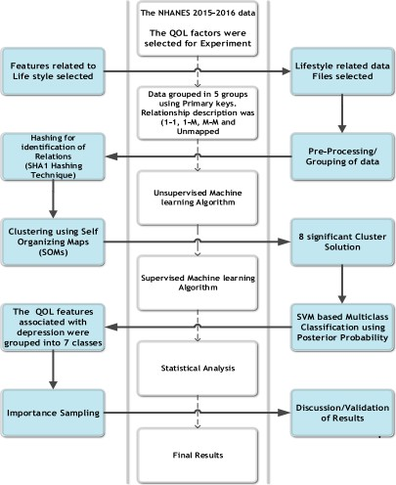

Figure-1 System Architecture

DATA FLOWDIAGRAM:

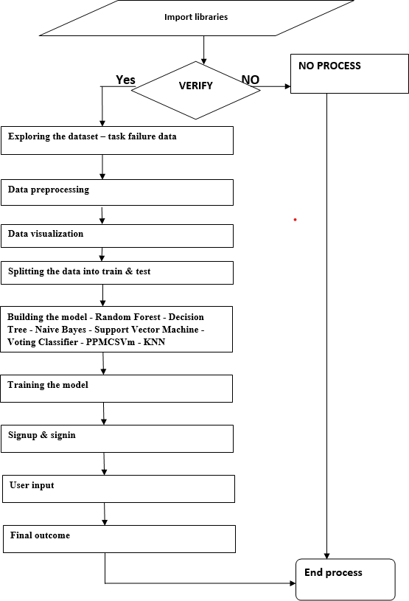

Figure- 2 Data Flow Diagram

UML DIAGRAMS:

CLASS DIAGRAM

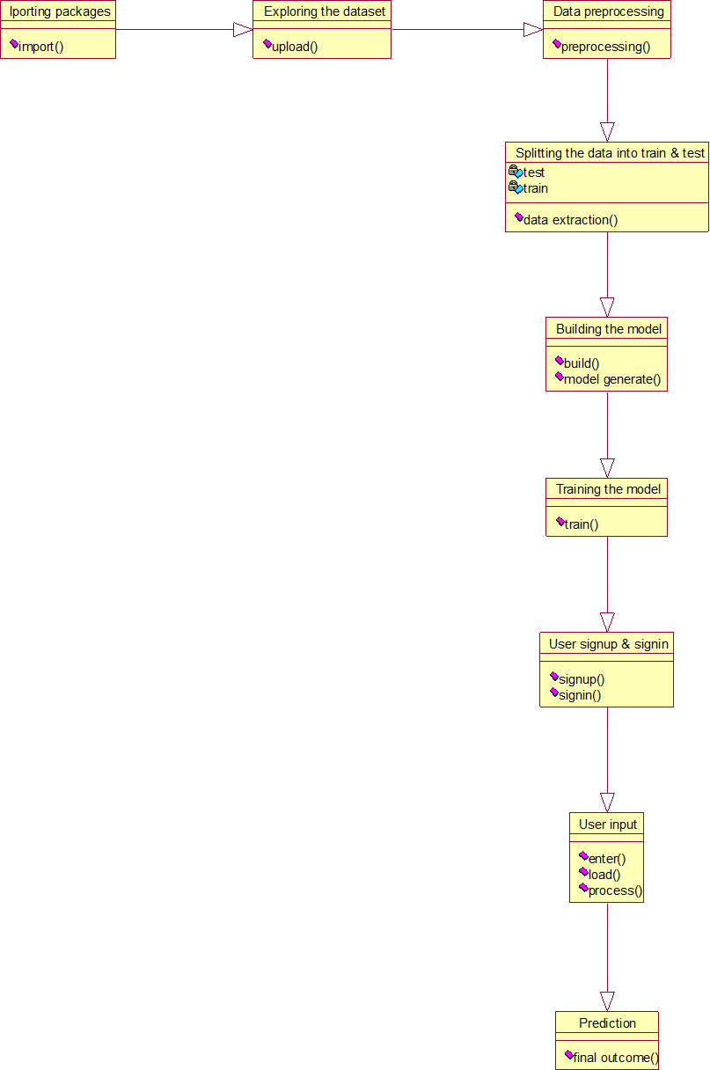

Figure-3 Class Diagram

USE CASE DIAGRAM:

Importing the packages

Exploring the dataset

Data preprocessing

Splitting the data to train & test

User

Model building

Training the model

User signup & signin

User input

Final outcome

Figure-4 Use Case Diagram

    - SEQUENCE DIAGRAM:

User
System

Importing the packages
Eploring the dataset
Data preprocessing
Splitting the data into train & test
Building the model - Random Forest - Decision Tree - Naive Bayes - Support Vector Machine - Voting Classifier - PPMCSVm - KNN
Training the model
User signup & signin
User gives input as text
Final outcome

Figure-5 Sequence Diagram

    - ACTIVITYDIAGRAM:
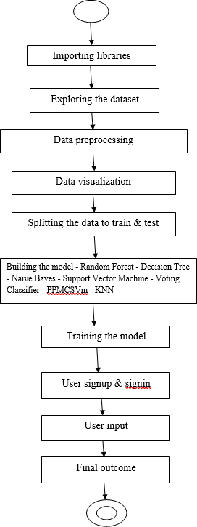

Figure-6 Activity Diagram

MODULES:

TENSORFLOW

Tensor Flow is a versatile and widely-used platform that has been widely adopted in the fields of machine learning and artificial intelligence. It provides a powerful and flexible set of tools for dataflow and differentiable programming, making it an ideal choice for a range of tasks in research and development. From image and speech recognition to natural language processing and robotics, TensorFlow has been used in a wide variety of applications across different industries.

One of the key strengths of Tensor Flow is its ability to handle large amounts of data and perform complex computations quickly and efficiently. This has made it a popular choice for both academic research and commercial applications. The library is designed to work seamlessly with a range of programming languages, including Python, C++, and Java, making it easy to integrate into existing software systems.

TensorFlow was initially developed by the Google Brain team for internal use at Google. However, in 2015, it was released under the Apache 2.0 open-source license, making it available for use by the wider research and development community. Since then, TensorFlow has gained a large and active community of users and contributors, who have contributed to its ongoing development and helped to shape its future direction. As a result, TensorFlow has become one of the most widely-used and well-regarded machine learning libraries available today.

NUMPY

Numpy is a highly versatile and efficient array-processing library that provides a variety of tools for working with multidimensional arrays. Its primary use case is in scientific computing with Python, and it offers a range of essential features that make it a fundamental package for data analysis.

One of Numpy's most significant features is its powerful N-dimensional array manipulation capabilities. This functionality allows users to easily manipulate and

operate on large datasets with ease, making it an ideal tool for data analysis tasks that involve working with multi-dimensional arrays.

Numpy also offers sophisticated broadcasting capabilities, which allows for more efficient computation and manipulation of arrays. Broadcasting is the process of performing operations on arrays of different shapes and sizes, and Numpy's broadcasting capabilities allow users to do this with ease.

In addition to its array manipulation features, Numpy also provides tools for integrating C/C++ and Fortran code. This is especially useful for scientific computing tasks that require the use of external libraries or modules.

Numpy also offers a variety of mathematical functions, including useful linear algebra, Fourier transform, and random number capabilities. These features make it a highly versatile tool for a wide range of scientific computing tasks.

Furthermore, Numpy can also be used as a highly efficient and flexible container for storing and manipulating non-specific data. Users can define arbitrary data types using Numpy, allowing for seamless and rapid integration with a wide variety of databases.

Overall, Numpy is a highly valuable tool for scientific computing and data analysis tasks, offering a wide range of features and capabilities that enable users to work with large datasets with ease and efficiency.

PANDAS

Pandas is an open-source Python library that provides a powerful data manipulation and analysis tool using its efficient data structures. Previously, Python was primarily used for data munging and preparation, with very little focus on data analysis. However, Pandas has resolved this issue by providing users with a simple and intuitive way to handle and analyze data, regardless of its source.

With Pandas, users can complete five common steps in the processing and analysis of data: loading data into memory, cleaning and manipulating data,

modeling data, analyzing data, and visualizing data. The library provides a range of functions and tools that allow users to perform these steps with ease and efficiency. Python with Pandas is used in a wide range of fields, including academic and commercial spaces such as finance, economics, statistics, analytics, and more.

Its flexibility and versatility make it an ideal tool for any task that involves working with data. One of the key features of Pandas is its ability to handle and manipulate large datasets with ease. The library provides data structures such as Series and DataFrame, which allow users to store and manipulate large amounts of data in memory efficiently.

Additionally, Pandas provides a wide range of functions for cleaning and transforming data, making it easy to prepare data for analysis.Another major advantage of using Pandas is its ability to integrate with other Python libraries, such as NumPy, Matplotlib, and Scikit-learn. This allows users to perform advanced data analysis and modeling tasks using a single programming language.

In summary, Pandas is a powerful and efficient tool for data analysis and manipulation in Python. Its intuitive data structures and functions make it easy to work with large datasets, while its flexibility and versatility make it suitable for a wide range of applications.

MATPLOTLIB

Matplotlib is a widely-used Python 2D plotting library that produces high-quality figures in a variety of output formats, including hardcopy formats and interactive environments across platforms. It is a versatile tool that can be used in Python scripts, IPython shells, Jupyter Notebooks, web application servers, and graphical user interface toolkits. Matplotlib aims to make simple things easy and complex things possible.

With just a few lines of code, users can create a wide range of visualizations, including plots, histograms, power spectra, bar charts, error charts, scatter plots, and more.For basic plotting, the pyplot module provides a MATLAB-like

interface, particularly when combined with IPython. This makes it easy for users who are familiar with MATLAB to quickly get up to speed with Matplotlib.

For more advanced users, the library provides a full range of customization options, allowing for complete control over line styles, font properties, axis properties, and more. This can be done through an object-oriented interface or a set of functions that will be familiar to MATLAB users. Matplotlib provides a wide range of tools and features to enable users to create professional-quality plots and visualizations.

The library is highly customizable, with many different options for controlling the appearance of plots, including the ability to customize axis labels, titles, legends, and more. Additionally, Matplotlib is compatible with a wide range of data formats, making it easy to create visualizations from data stored in CSV files, databases, and other formats.

Overall, Matplotlib is a powerful and flexible tool for data visualization in Python. Its intuitive interface and extensive customization options make it easy to create high-quality visualizations, while its compatibility with a wide range of data formats and environments makes it a versatile tool for a wide range of applications.

SCKIT – LEARN

Scikit-learn is a Python library that provides a wide range of supervised and unsupervised learning algorithms through a consistent interface. The library is distributed under a permissive BSD license, and is widely available through Linux distributions, making it a popular choice for both academic and commercial use.

Scikit-learn provides a wide range of machine learning algorithms, including classification, regression, clustering, and dimensionality reduction. These algorithms can be used for a variety of tasks, such as predicting the outcome of a decision or clustering similar data points together. The library also provides tools for model selection and evaluation, as well as data preprocessing and feature extraction.

One of the key advantages of scikit-learn is its ease of use. The library provides a consistent interface for all of its algorithms, making it easy to switch between different models and experiment with different parameters. Additionally, scikit- learn provides extensive documentation and examples, making it easy for users to get started and learn how to use the library effectively.

Scikit-learn is also highly optimized for performance, with many of its algorithms written in Cython or C for speed. This allows the library to handle large datasets and complex models efficiently, making it a popular choice for big data and machine learning applications.

Overall, scikit-learn is a powerful and flexible machine learning library that provides a wide range of algorithms and tools for data analysis and modeling. Its ease of use and performance make it a popular choice for both beginners and experts alike, and its permissive license makes it accessible to a wide range of users.

        - IMPLIMENTATION AND RESUTS

5. IMPLIMENTATION AND RESUTS

LANGUAGE/ TECHNOLOGYUSED:

PYTHON

Python is a versatile programming language that has gained immense popularity due to its wide range of applications in various fields such as web development, data analysis, scientific computing, and more. One of the major advantages of Python is its ability to support both object-oriented and procedural programming styles, which makes it a flexible tool for programmers to work with.

Apart from its versatility, Python has also become popular due to its ease of use and readability. Python code is generally more concise than other programming languages like Java, which allows programmers to write code more efficiently and quickly. This simplicity of the language allows programmers to focus on the actual problem they are trying to solve, rather than getting bogged down in complex syntax and rules.

Furthermore, Python's simple and consistent syntax makes it easy to read and comprehend even for those who are new to programming. This feature has made Python a preferred choice for beginners who want to learn programming. The clean and organized structure of Python code also makes it easier to debug, maintain and collaborate with other developers.

In summary, Python's versatility, ease of use, and readability have made it a popular programming language among developers. It allows them to focus on solving problems efficiently and effectively without getting lost in complex syntax or rules, making it a great tool for programmers of all levels of experience.

ADVANTAGES OF PYTHON

- EXTENSIVE LIBRARIES

One of the key advantages of Python is its extensive library of modules and packages, which provide pre-written code for a wide variety of tasks. This means that programmers can save time and effort by using pre-existing code, rather than writing everything from scratch.

Python's library includes modules for tasks like regular expressions, documentation generation, unit testing, web browsers, threading, databases, CGI, email, image manipulation, and more. This makes it easy for developers to perform common programming tasks without having to write the code themselves.

For example, the regular expressions module provides a powerful tool for searching and manipulating text, while the unittest module provides a framework for writing and running automated tests. The built-in threading module allows programmers to create multi-threaded applications, while the urllib module makes it easy to access web content.

In addition to the built-in modules, Python has a vast array of third-party packages that can be installed to add additional functionality to the language. These packages include popular data analysis tools like Pandas and NumPy, web development frameworks like Django and Flask, and many others.

Overall, Python's extensive library of modules and packages is one of the key factors that has contributed to its popularity as a programming language. By providing pre-written code for a wide range of tasks, Python allows developers to work more efficiently and effectively.

EXTENSIBLE
Python exhibits a significant strength in its capacity to be integrated into other programming languages, enabling developers to incorporate scripting functionalities into their pre-existing codebase. The utilization of Python code

within another programming language, such as C++, enables the developer to capitalize on the respective advantages offered by both languages.

As an illustration, Python is suitable for executing high-level scripting and automation undertakings, whereas C++ is suitable for executing low-level system programming or performance-critical operations. Incorporating Python within an alternative programming language is ostensibly uncomplicated as a result of the accessibility of the Python C API. This interface offers a collection of functions, thereby facilitating the process of embedding Python in C or C++ code.

With the aid of the API, software developers are able to generate Python objects, invoke Python functions, and operate on Python data structures within the confines of their C or C++ programming.This methodology may prove advantageous in domains that necessitate scripting capacities or dynamic characteristics, such as scientific simulations or video games.

EMBEDDABLE

Python exhibits a notable strength in terms of its potential for integration into disparate programming languages, thus enabling software developers to incorporate scripting functionalities into their extant codebase.

The integration of Python code within a distinct language, such as C++, facilitates the capacity of developers to leverage the distinctive competencies of each language. As an illustration, Python is well-suited for executing high-level scripting and automation tasks, whereas C++ can be employed for low-level system programming or performance-critical operations.

Incorporating Python into another programming language is deemed to be a relatively simple task, predominantly due to the ready accessibility of the Python C API. This particular application programming interface (API) proffers a collection of functions that facilitate the embedding of Python into C or C++ code.

By utilizing the Application Programming Interface (API), software developers are enabled to generate Python objects, invoke Python functions, and execute modifications in Python data structures through their respective C or C++ code.

This methodology can prove to be notably advantageous for implementations that necessitate scripting faculties or dynamic conduct, including but not limited to video game development or scientific simulations. Through the integration of Python into their codebase, software developers can efficiently incorporate robust scripting capabilities into their applications, while avoiding the need to restructure their entire codebase in Python.

IMPROVED PRODUCTIVITY

Python's streamlined design and comprehensive suite of libraries render it a remarkably efficient language, enabling software engineers to achieve greater productivity with reduced coding requirements and diminished development time in contrast to alternative languages such as Java and C++.

Python's syntax is simple and legible, thus facilitating a swift grasp of the programming language's learning, usage, and maintenance aspects. This language empowers developers to write code with remarkable expeditiousness and effectiveness. Moreover, Python's extensive repertoire of pre-existing libraries and third-party packages present an abundance of pre-established functionalities, obviating the need for developers to expend their resources and labor on original coding efforts.

The aforementioned productivity edge proves exceptionally advantageous in the context of vast endeavors or intricate software programs, where the accumulation of development time and expenses can transpire expeditiously. Python facilitates the expeditious and more scrubbed construction of applications by developers, consequently enabling a quicker time-to-market and bolstered economization.

In summary, the straightforwardness and extensive collections of Python render it a fit-for-purpose language for a diverse assortment of undertakings encompassing web development, data scrutiny, scientific computation, and artificial intelligence.

IOT OPPURTUNITIES
Python's adaptability and cross-platform compatibility render it a highly suitable programming language for developing applications catering to the fundamental structure of the Internet of Things (IoT). This technology involves the intercommunication of real-world objects with the internet, aiding in the acquisition and transfer of data in diverse environments.

Python has a multitude of advantages that render it highly applicable for Internet of Things (IoT) use cases. Specifically, its lightweight nature and ease of acquisition make it a preferred language for IoT development. Additionally, Python's extensive collection of libraries and tools further enhances its utility for building IoT applications.

The software is compatible with diminutive equipment such as the Raspberry Pi. The latter is extensively favored by innovators for constructing Internet of Things (IoT) undertakings.

Python’s capabilities in facilitating various communication protocols such as MQTT and HTTP enable seamless integration of devices and sensors with online services. Furthermore, the versatility of Python in managing various data formats such as JSON, XML, and CSV endows it with an aptitude for scrutinizing and manipulating data originating from Internet of Things (IoT) devices.

Python's aptitude for Internet of Things (IoT) applications, coupled with its flexibility and extensive library collections, render it a favored option for the development of IoT projects and the interconnection of tangible apparati to the web.

SIMPLE AND EASY
In recent years, Python has garnered a reputation as an introductory programming language that boasts a high degree of accessibility and user-friendliness, primarily

attributable to its basic and user-friendly features. The syntax of this language is recognized for its inherent intuitiveness and comprehensibility, rendering it amenable to even those who are novices in the field of coding.

Furthermore, the language's elevated-level structures facilitate software engineers to attain greater functionality with a reduced amount of code, thereby enhancing the speed and efficiency of task execution.

Furthermore, Python's inherent readability renders it highly favored by developers engaged in collaborative team environments. The lucid and succinct structure of the code guarantees facile comprehension and effective upkeep by a multitude of developers, including those who may not possess familiarity with the undertaking.

Moreover, the versatility of Python constitutes a critical component that enhances its extensive adoption in diverse disciplines. The versatility of the programming language renders it a desirable choice amongst developers seeking the ability to leverage their technical competencies across diverse domains such as web development, scientific computing, data analysis, artificial intelligence and beyond.

READABLE

Python is a widely used programming language characterized by its high-level nature, offering a syntax that is renowned for its clarity and comprehensibility. One of the contributing factors to the linguistic accessibility of the language in question is the conscious design of its syntax to resemble that of the English language.
This facilitates the development of code in a fashion that closely mimics a natural language, thereby rendering it more comprehensible for non-developers. In contrast to several other programming languages, the block definition process in Python is not reliant on the utilization of curly braces.
The accentuation of indentation to signify diverse blocks of code is underscored instead. The aforementioned proposition imbues the code with enhanced aesthetic resonance, enhanced comprehensibility, and superior organization. The stringent

implementation of whitespace restrictions in Python is enforced by the Python interpreter.
Through the implementation of an automated formatting and standardization process, a high degree of consistency and improved legibility throughout the codebase is facilitated. Python facilitates the development of high-quality software systems by promoting the production of code that is comprehensible and unambiguous.
The ease with which developers can write and comprehend Python code fosters the creation of software that is readily maintainable and modifiable, thereby underscoring its significance in ensuring the sustainable success of any software venture.

FREE AND OPEN-SOURCE

The programming language, Python, possesses versatility and dynamism, leading to an exponential increase in its popularity and adoption throughout the years. Python's exceptional attribute lies in its unrestricted accessibility as a programming language, wherein it can be effortlessly procured and downloaded sans any monetary compensation.

Moreover, the open-source architecture of Python enables users to gain access to its underlying source code, customize it in accordance with their specific requirements and inclinations, and subsequently disseminate it to others as desired. The adaptability inherent in the Python programming language has rendered it exceedingly popular among software developers and coders. This quality empowers these professionals to design and tailor their proprietary software and utilities on the Python platform.

Additionally, Python boasts a vast collection of modules and packages that furnish a diverse range of functionalities, rendering it an optimal selection for a plethora of assignments, projects, and applications. The present libraries proffer an assortment of modules encompassing data analysis, web development, scientific computing, and a plethora of other services. Python has gained widespread popularity as a programming language owing to its highly intuitive syntax, robust functionality, and a large cohort of adept professionals contributing to its development.

OBJECT-ORIENTED

The successful and widely acclaimed utilization of Python can be attributed to its adherent implementation of object-oriented programming paradigms. Python facilitates the organization and management of code for developers by means of encapsulating data and functions within objects. The method of object-orientation enables the consolidation of linked data and functions within a singular unit, thereby streamlining the developmental trajectory and facilitating the code's longevity as it relates to subsequent maintenance.

Furthermore, the support for methods within Python enables seamless interaction between objects, affording a more intuitive and organic means of representing real-world problems in code. Python provides programmers with the option to select the most suitable programming paradigm and approach, be it procedural or object-oriented. This remarkable feature enables developers to tailor their coding methods to their individual preferences and specific requirements.

Python's broad utility across diverse domains has rendered it a highly preferred option for several applications and industries encompassing web development, data science, machine learning, and additional areas. Consequently, Python has attained widespread adoption as a programming language worldwide, owing to an active consortium of developers persistently exploring novel applications and expanding the potential of this robust toolset.

PORTABLE

Python is characterized by a noteworthy feature of platform-independence. As a high-level programming language, Python offers a concise and coherent syntax that supports ease of comprehension and composition for developers with diverse backgrounds and expertise. The previously mentioned feature facilitates the development of cross-platform applications that possess the capability to function on varying operating systems without necessitating modifications to the source code.

Python code is subjected to an initial compilation process, wherein it is transformed into an intermediate bytecode format. The current bytecode demonstrates platform independence as it is capable of execution on any

operating system with the presence of a Python interpreter installation. The aforementioned characteristic confers the ability to execute Python code on a plethora of computing platforms without necessitating any alterations pertinent to any particular platform.

The aforementioned statement suggests that it is a viable option to construct a Python software application on a Windows operating system and subsequently deploy it on an alternative platform such as a Mac or Linux device, without encountering any functional aberrations or hindrances. Python's platform- independence attributes provide a considerable advantage by reducing both development duration and expenses.

Python affords developers with a platform-agnostic environment to focus on the logic and syntax of code, free from the distraction of platform-specific complexities that may arise. Additionally, Python offers diverse tools and data structures that facilitate the development of multifaceted software systems, making it an outstanding option for programmers seeking to build applications with cross-platform compatibility.

INTERPRETED

Python is a programming language that is characterized by its high level of abstraction, user-friendliness, and adaptability. Python possesses an exceptional attribute that distinguishes it from other programming languages: it is an interpreted language. Consequently, the execution of code in Python involves the interpreter processing each line of code at runtime, thereby obviating the requirement for a distinct compilation phase.

This facilitates the testing and debugging processes for developers, affording them the opportunity to observe the outcomes of individual lines of code during execution. In contradistinction, compiled programming languages necessitate the translation of code into machine-readable instructions prior to their implementation.

The inability to inspect the outcomes of individual lines of code until the comprehensive compilation and execution of the entire program can lead to increased complexity of the debugging process for developers. The interpretive

nature of Python confers the advantage of facilitating efficient and streamlined modifications and updates to code, without necessitating a comprehensive recompilation process.

This capacity allows for expedient and effective testing and integration of changes to the codebase. The malleability and user-friendly nature of Python have rendered it a favoured option across an extensive spectrum of applications, including web development, scientific computation, and artificial intelligence.

ADVANTAGES OF PYTHON OVER OTHER LANGUAGES

- LESS CODING

The standard library of Python is a highly remarkable feature that bestows developers with an extensive array of tools and functionalities. These can be effectively employed for diverse tasks and pursuits. The voluminous repository comprises of modules that encompass file manipulation, networking, web development, data modification, and a host of other functionalities, thus rendering it feasible to execute sundry operations sans external libraries or dependencies.

Python's plethora of functionality offered within its standard library has rendered it a well-received option for novices and proficient programmers alike. Novices can readily initiate their programming endeavors with Python and draw on its standardized library to gain insight into diverse programming concepts and functionalities. Python's syntax boasts of simplicity and readability that make it possible for seasoned developers to take advantage of it.

Through the reduction of code needed to perform tasks, writing and maintaining code is made simpler. The user-friendly syntax of Python renders it more comprehensible for individuals without programming expertise, hence facilitating their comprehension and mastery of this programming language.

Python has gained enormous popularity as a programming language owing to its accessible and comprehensive standard library, which has facilitated its widespread utilization. Furthermore, an active cohort of developers have consistently endeavored to augment and enhance the language's functionality, thus fostering a robust community of practitioners.

AFFORDABLE

Due to Python's open-source nature and the abundance of free resources at its disposal, it has garnered wide usage among a diversity of users encompassing individuals, small enterprises, and large corporations alike. Python, an open- source programming language, presents a cost-free opportunity for both usage and dissemination, thereby extending accessibility to developers worldwide.

The present scenario has resulted in the flourishing community of Python users that are perpetually engrossed in the development of novel libraries, frameworks, and tools, effectively augmenting the language's extensibility. The active user community of Python plays a significant role in enhancing the language's popularity, by offering support and sharing resources to facilitate learning and adoption among novice users.

In view of its versatility and user-friendly attributes, Python has emerged as one of the most popularly utilized programming languages on a global scale. The straightforward and easily comprehensible syntax of the programming language facilitates swift and effective coding practices for developers. The extensive assortment of libraries and frameworks furnished by the language furnish an array of resources that enable the development of applications with minimal exertion.

Python has emerged as a highly favored alternative for multiple applications, encompassing web development, scientific computation, and artificial intelligence. The presence of these resources has contributed to the development of a cooperative and encouraging community of programmers that persistently strives to enhance and extend the linguistic potentialities.

PYTHON IS FOR EVERYONE

Python, with its versatility and user-friendly characteristics, has emerged as a powerful programming language that is increasingly gaining popularity among software developers. The Python programming language boasts a remarkable advantage in its capacity to be executed across a wide range of operating systems, encompassing not only Linux, but also Mac and Windows environments.

Python's cross-platform compatibility attribute makes it an attractive choice for developers who are involved in work across a multifaceted set of machines, or who are assigned with the responsibility of designing software applications that can be executed on multiple platforms. Furthermore, the versatile and intricate characteristics of the Python programming language enables software developers to expand their understanding of diverse coding languages in order to effectively meet a range of professional requirements.

The Python programming language has gained significant traction in the sphere of web application development, rendering it a fundamental language to be proficient in for software engineers aspiring to specialize in this area. Python is commonly employed in the analysis of data and machine learning, thereby establishing itself as a crucial tool for professionals in the fields of data science and analysis.

Furthermore, its utility extends to web development as well. Python's capabilities extend beyond the realms of web development and data analysis. The utilization of this tool in order to automate a wide array of tasks represents a significant benefit for system administrators and DevOps engineers. Python, a versatile programming language, is endowed with the capability to execute web scraping, which is the retrieval of information from websites.

The topic under consideration is a practice that has gained significant traction across various sectors, specifically within the domains of marketing and finance. Python demonstrates the capacity to develop games and powerful visualizations, thereby conferring upon it a multifaceted nature suitable for innovative endeavors.

Python has become a prominently recognized programming language on a global scale due to its efficient functionalities and approachable user interface. Hence, the said phenomenon has accumulated an extensive adhering populace, and its prevalence is predicted to soar in the imminent horizon.

DISADVANTAGES OF PYTHON

- SPEEDLIMITATIONS
The interpreted nature of Python may lead to relatively sluggish execution times in comparison to compiled programming languages. Notwithstanding, for the most part, the pace of implementation within the Python programming language is not a substantial concern. The benefits of Python, including its user- friendliness, interpretability, and extensive collection of libraries and frameworks, frequently supersede any constraints in terms of velocity.

Python, owing to its simplicity and readability, renders the task of writing and managing code simpler, while the availability of its expansive libraries and frameworks empowers developers to create intricate applications with minimal exertion.

Python's multifaceted nature renders it applicable across a diverse spectrum of domains, spanning from the development of web-based platforms to the realm of data science and even artificial intelligence. In certain scenarios, expeditiousness may hold paramount significance; however, the advantageous qualities of Python render it a favored option for a multitude of undertakings where celerity is not the foremost priority. Python's numerous advantages render it a compelling choice for programmers seeking to develop software characterized by enhanced efficiency and high-quality standards.

WEAK IN MOBILE COMPUTING AND BROWSERS

Although Python is not frequently utilized for client-side development, it can still be applied in specific situations within this domain. Python has the capability to create desktop applications that are operational on a user's device without requiring an internet connection. Furthermore, Python can be employed alongside web technologies such as HTML, CSS, and JavaScript to formulate interactive web systems.

It has been stated that there exist alternative languages and frameworks more appropriate for client-side development. An instance of this would be that web browsers have built-in support for JavaScript and it is the dominant language employed for the development of the client-side.

React Native, a prevalent framework in mobile app development, utilizes JavaScript and has garnered attention for its capability to establish applications compatible with multiple platforms.Python's client-side development may not be as secure due to its dynamic typing and high-level abstractions. Due to the fact that client-end programming runs on the device owned by the user, ensuring security is of utmost importance.

Despite implementing protective mechanisms like cleansing user inputs, Python may not offer the highest level of security for developing client-side applications. In general, although Python may not be the preferred programming language for developing on the client-side, it still holds significance in certain scenarios and can be a beneficial resource if used appropriately.

DESIGN RESTRICTIONS

Notwithstanding, Python presents mechanisms that can effectively manage the occurrence of aforesaid errors. The feature of type hints in Python enables developers to explicitly indicate the anticipated type of variables and arguments utilized within functions. Although not mandated by the Python interpreter, these classificatory cues can be verified with the aid of supplementary software and facilitate error detection in the course of software development.

Moreover, Python presents an integrated mechanism for handling exceptions that empowers developers to effectively detect and manage runtime errors in a graceful manner. This implies that in the event of a runtime error, the program can persist in its execution, and the error can be managed suitably.

In totality, the utilization of dynamic typing in the Python language may prove to be a two-fold instrument, whereby its utilization poses both benefits and drawbacks. However, it may potentially endow convenient facilitation and adaptability in certain contexts. In the realm of programming language features, it is essential for developers to possess an intricate comprehension of the advantages and drawbacks of said features in order to effectively employ them in a fitting manner.

UNDERDEVELOPED DATABASE ACCESS LAYERS

Python comprises various modules that enable developers to gain access to databases; however, they are deemed to be less developed compared to more established technologies like JDBC and ODBC. The Java Database Connectivity (JDBC) is a frequently utilized application programming interface (API) that offers a standardized means to establish connections with relational databases. Conversely, Open Database Connectivity (ODBC) is a proprietary standard for obtaining data from databases that was developed by Microsoft.

In contrast, the database access layers in Python are currently undergoing a continuous process of development, hence may lack the comparable level of functionality and stability evident in more established technologies.Nonetheless, the present-day data access modules of Python, namely SQLite3, MySQL, and PostgreSQL, continue to possess a considerable degree of operational efficiency and enjoy widespread employment.

Despite being a relatively nascent development, these technologies provide a gamut of features encompassing transaction management, stored procedures and prepared statements. Furthermore, the Python programming language offers extensive libraries, namely Pandas and NumPy, for data analysis and machine learning, which can effectively interface with these modules to facilitate robust data manipulation and analysis capabilities.

Although certain apprehensions regarding Python's reliability and scalability may cause hesitation among large enterprises when it comes to employing it for database access, the language's capabilities in disparate domains, particularly data analysis and machine learning, render it an immensely valuable resource for numerous other applications. The development and advancement of Python's database access layers are anticipated to result in heightened uptake of the programming language within this domain.

SIMPLE
Python's minimalist complexity and simplified syntax have received widespread acclaim as a significant attribute, positioning it as a distinguished advantage.

Python's capacity to function as a programming language for both inexperienced and experienced individuals arises from its easily comprehensible nature and its ability to accelerate the process of prototyping and development within a reasonable timeframe.

However, the characteristics that bestow upon Python its popularity as a programming language can be counterintuitively perceived as shortcomings in specific scenarios. The inadequate level of verbiage present in Python programming has the potential to yield perplexity and inaccuracies, especially when dealing with complex and elaborate software endeavors.

In circumstances of this nature, programming code is prone to appearing as intricate and formidable to grasp, leading to decreased efficiency and compromised overall output excellence. Furthermore, the simplified nature of Python programming language could potentially give rise to a scarcity of meticulousness in programming methodologies such as testing and documentation, ultimately leading to inadequately developed and unfruitful code.

Despite the potential limitations of Python's straightforward nature in particular contexts, this programming language continues to be widely utilized and highly versatile.To overcome the plausible shortcomings pertaining to the elementary nature of Python, programmers may elect to utilize optimal methodologies, including the adoption of code reviewing, testing protocols, and documentation procedures. This will ensure that the code continues to preserve its comprehensibility, flexibility, and efficiency, notwithstanding its degree of complexity.

SAMPLECODE:

# Importing numpy and setting a random seed
importnumpyasnp np.random.seed(123)
# Importing packages and setting a couple of style options
importpandasaspd importglob,os importmatplotlib.pyplotasplt
%matplotlib inline importseabornassns sns.set(style='whitegrid') importwarnings warnings.filterwarnings('ignore')
# Setting pandas to display max columns and rows pd.set_option('display.max_columns',0) pd.set_option('display.max_rows',None)
# Setting pandas inf values to be nan
pd.set_option('mode.use_inf_as_na',True)
# Turning off scientific notation in pandas pd.set_option('display.float_format',lambdax:'%.3f'%x) # This will cause the project functions py file to keep refreshed
%load_extautoreload
%autoreload 2
# Loading in the custom project functions and some tools to look at them
importproject_functionsaspf importinspect
fromIPython.displayimportMarkdown,display # Looking at function func=inspect.getsource(pf.glob_concat) display(Markdown("```python\n"+func+"\n```")) # Combining all the files for the target path=r'Data/Target' df_target=pf.glob_concat(path,'*.XPT')
# Dropping the final column
df_target.drop(columns=['DPQ100'],inplace=True)
# Checking the null values
df_target.isna().sum()
# Looking at the pattern of null values importmissingnoasms ms.matrix(df_target);
# Removing all null entries
df_target.dropna(inplace=True)
# Checking for null values and how many entries are left
df_target.info()
# Looking at function that performs .value_counts() func=inspect.getsource(pf.val_counts) display(Markdown("```python\n"+func+"\n```"))
# Looking at the values for the columns
pf.val_counts(df_target)
# Removing the entries that contain ambiguous answers(7 and 9)

df_target=df_target[(df_target!=7)&(df_target!=9)] # Checking that the 7s and 9s are removed pf.val_counts(df_target)
# Checking the entries
df_target.info()
# Looking at null values
df_target.isna().sum()
# Creating the target column based on the value in the total column
df_target['depression']=df_target.Total.apply(
lambdax:'Not Depressed'ifx<10else'Depressed')
# Slicing out only the target column into its own DataFrame target_clean=pd.DataFrame(df_target['depression']) target_clean.head()

RESULTS (ACCURACY)/OUTPUTSCREENS:
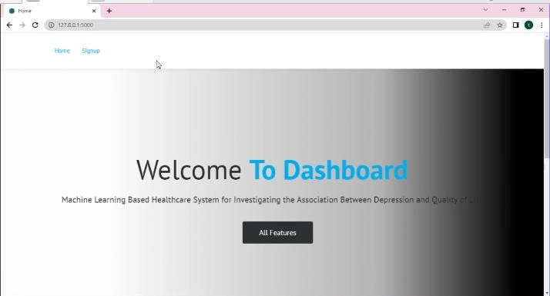

Figure-7 Image of Dashboard

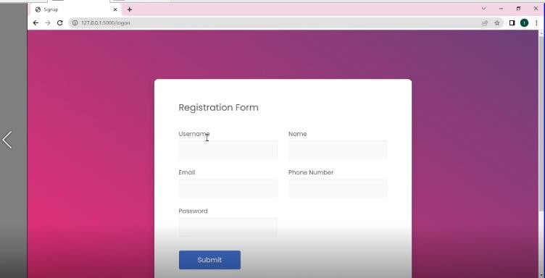

Figure-8 Image of Registration Form

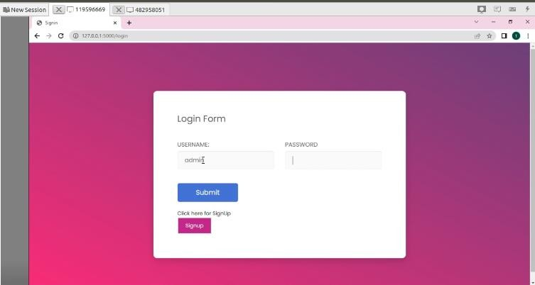

Figure-9 Image of Login Form

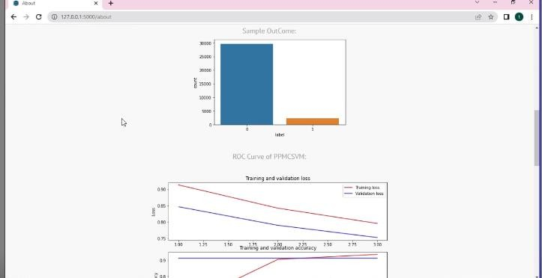

Figure -10 Image of Out Come Graph

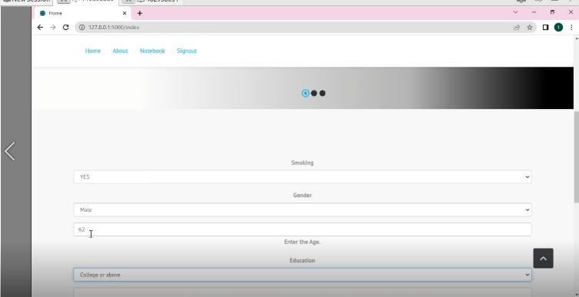

Figure-11 Form Filling-I

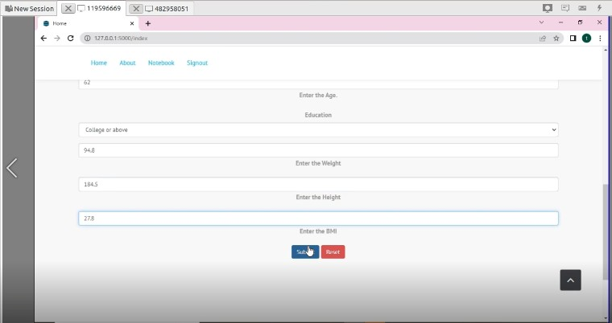

Figure-12 Form Filling-II

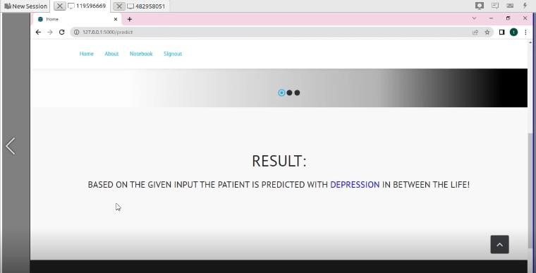

Figure-13 Result Page

6.TESTING

TESTING

TYPES OF TESTING

UNIT TESTING

Unit testing is a crucial component of the software development process that helps to ensure the functional correctness of individual software modules. By testing each module in isolation, developers can quickly identify and fix defects, ensuring that the overall system works as intended.

There are several unit testing strategies that developers can use to test software modules. One common strategy is black box testing, which involves testing the module from an external perspective. In black box testing, the module is treated as a "black box" whose inputs and outputs are known, but the internal workings of the module are not examined. This approach is useful for testing the module's behavior under various inputs and conditions.

Another strategy is white box testing, which involves testing the module from an internal perspective. In white box testing, the module's internal structure and code are examined to ensure that all possible execution paths are tested. This approach is useful for testing complex modules or those with complex control structures.

In addition to these strategies, there are other techniques that developers can use to ensure the functional correctness of their software modules. For example, boundary value testing involves testing the module at the boundaries of its input and output ranges, while equivalence partitioning involves dividing the input and output spaces into equivalent classes and testing each class.

In conclusion, unit testing is a critical part of the software development process, and there are many strategies and techniques that developers can use to ensure the functional correctness of their software modules. By testing each module in isolation and using a variety of testing approaches, developers can identify and fix defects quickly and efficiently, ensuring that the overall system works as intended.

DATA FLOW TESTING

Data flow testing is a powerful testing methodology that focuses on analyzing the flow of data through a program's control flow. The goal of data flow testing is to identify any potential defects or bugs in the code that could result from incorrect handling of data objects or variables.

Data flow testing is based on the idea that variables or data objects can have different values at different points in the program's execution. By carefully selecting the paths through the program's control flow that involve changes to these values, testers can identify potential bugs or defects related to the program's handling of data.

In data flow testing, the focus is on the points at which variables or data objects are created, modified, or destroyed. By analyzing the program's control flow at these points, testers can identify potential defects related to data handling, such as uninitialized variables or data objects with incorrect values.

There are several techniques and tools that can be used for data flow testing, including data flow diagrams, control flow graphs, and data flow analysis tools. These tools can help testers identify potential data flow issues and track the flow of data through the program's control flow.

In conclusion, data flow testing is an important methodology for testing the flow of data through a program's control flow. By carefully selecting the paths through the program that involve changes to variables or data objects, testers can identify potential defects or bugs related to data handling, ensuring the overall quality and reliability of the software.

INTEGRATION TESTING
Integration testing is a testing methodology that is performed after unit testing has been completed. It is the next step in the testing process, and involves testing the integration between the individual units or modules that were tested during unit testing.

The purpose of integration testing is to ensure that the individual units or modules of the software work together as intended, and that the system as a whole is functional, performs well, and is reliable. Integration testing is critical to identifying any issues or defects that may arise from the interaction between the different components of the software.

During integration testing, the software is tested in a systematic way, by gradually adding and testing new components, until the entire system is tested as a whole. The testing process is typically automated, using a variety of tools and techniques, to ensure that all possible scenarios are covered and that the software performs as expected.

There are several types of integration testing, including top-down, bottom-up, and middle-out testing. Each of these approaches has its own strengths and weaknesses, and the choice of which approach to use depends on the specific needs of the project.

In conclusion, integration testing is a critical component of the testing process, and is performed to ensure that the individual units or modules of the software work together as intended, and that the system as a whole is functional, performs well, and is reliable.

By identifying and fixing any issues or defects that may arise from the interaction between the different components of the software, integration testing helps to ensure the overall quality and reliability of the software.

BIG BANG INTEGRATION TESTING

Big Bang Integration Testing is a type of integration testing where all the individual units or modules of the software are integrated and tested together all at once. This results in a complete system that is tested as a whole.

This type of testing methodology is often used in small projects or in situations where the software is relatively simple and the individual units are not too complex. However, it can also be a risky approach as it does not focus on

verifying the interaction between individual units, making it difficult to isolate and fix any errors or defects that may arise.

One of the major drawbacks of Big Bang Integration Testing is that it can be challenging to identify the source of any issues or defects that arise, as the entire system is tested as a whole rather than individual components being tested separately. This makes it more difficult to isolate and fix any errors that may arise.

Moreover, this type of testing can be time-consuming and expensive, as all the units need to be developed and ready for testing at the same time, and any issues or defects found during testing may require significant effort to resolve.
In conclusion, while Big Bang Integration Testing can be a quick and easy way to integrate all the units or modules of the software, it is often risky and can lead to difficulties in identifying and fixing issues or defects. As such, it is important to consider other integration testing approaches, such as incremental or modular integration testing, to ensure the overall quality and reliability of the software.

USER INTERFACE TESTING
The evaluation technique of user interface testing pertains to the identification of potential faults within the graphical user interface (GUI) of a software program or application. The central objective of testing the user interface is to ascertain the software's ease of use, intuitiveness, and user-friendliness.

The practice of GUI testing involves the meticulous examination and evaluation of various constituents that comprise the user interface such as buttons, menus, icons, text boxes, and other graphical elements. The process of testing entails the rigorous examination of the layout and design of the interface, coupled with the validation of the complete functionality of all constituent elements, as well as their commendable responsiveness in reaction to user input.

In the process of conducting user interface testing, automated tools and scripts are frequently utilized by testers to emulate the actions of a user interfacing with the software. This aids in the detection of potential concerns or deficiencies that may present themselves during routine utilization of the software.

The primary aim of conducting user interface testing is to ascertain the extent to which software conforms to the usability and accessibility standards stipulated for end-users. The process encompasses confirming the consistency and aesthetic appeal of the interface, alongside guaranteeing its accessibility to users who have disabilities.

In essence, user interface (UI) testing constitutes a crucial element of software testing, given its capacity to verify the user-friendliness of software and its alignment with end-users' requirements. The process of Graphical User Interface (GUI) testing enables testers to discern anomalies and malfunctions that pertain to the graphical features of the software. Consequently, it provides an opportunity for the detection and eventual rectification of such discrepancies prior to the software's dissemination to end-users.

TEST CASES
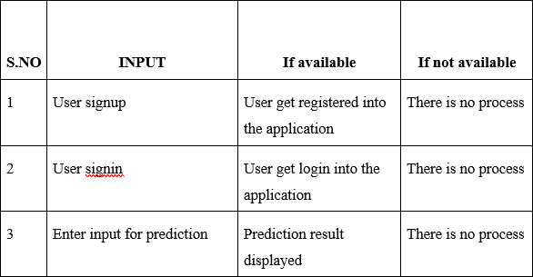

Table-1 Test Cases

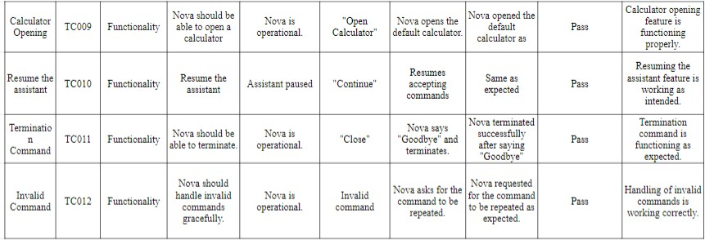
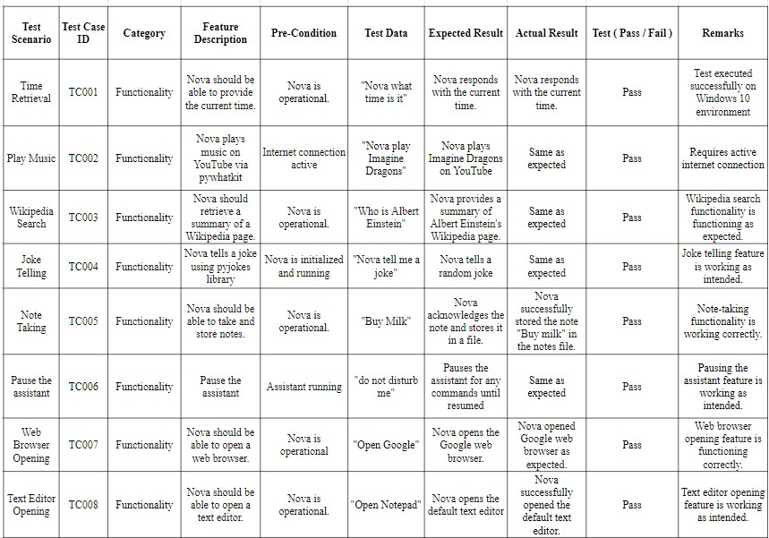

CONCLUSION

CONCLUSION

The identification and diagnosis of mental health disorders is widely regarded as a complex undertaking faced by healthcare professionals and related institutions. Based on the NHANES database, our study has unveiled an association between symptoms of depression and select factors associated with quality of life. In order to conduct thorough inquiry of the disparate data pertaining to mental health issues, clustering is a necessary initial step in the collation of factors associated with overall quality of life. The process of cluster rebuilding is carried out by means of self-organizing maps (SOM). In order to obtain an optimized classification, the data elements contained within the clusters are reorganized. The PPMCSVM is a modified version of the conventional Support Vector Machine (SVM) algorithm that serves the purpose of addressing classification problems and evaluating the correlation between data. To model the multi-class problem, the ECOC approach was employed and trained via the SVM methodology. Therefore, there have been discoveries indicating that the proposed program may be able to effectively predict the factors responsible for causing distress. The application of Significance Testing serves as a mechanism for determining optimal tests from a plethora of possible options, thereby facilitating the representation of the relationship between two distributions. The selection of tests is predicated on an evaluation of the proportion that serves as a compensatory factor to counterweigh the likelihood of bias arising from the distribution. Ultimately, the present investigation has discerned a correlation between anticipated determinants of quality of life and the experience of melancholy. Upon undertaking comparisons with prominent state-of-the-art strategies, along with currently published works, it has been determined that the outcomes of the proposed approach are considerably more robust. Future research endeavors are deemed necessary to further elucidate the dataset that encompasses an array of factors and delineate the severity levels of melancholy ascribed to various determinants. The figure that encompasses attributes of docility, elevation, and gravity in relation to discouragement is in question. This will provide aid and support to fellow analysts and clinicians in recognizing the potential risks associated with psychological distress and other forms of mental disorders.

FUTURE SCOPE

FUTURE SCOPE

Depression and quality of life are pertinent subjects of inquiry that have been extensively examined in the preceding literature. Notwithstanding, there exists a substantial opportunity for additional examination and scholarly inquiry within this domain. Possible future avenues for scholarly inquiry into the domains of depression and quality of life comprise.

The imperative for additional longitudinal investigations that conduct sequential assessments of individuals diagnosed with depression over the course of time persists, given their potential to augment comprehension regarding the inherent trajectory of the disorder and its impacts on an individual's quality of life.

Interventions aimed at depression warrant further empirical investigation with a view to identifying efficacious therapeutic modalities that holistically mitigate depressive symptoms while concurrently enhancing one's overall quality of life.

Possible interventions might entail enhancing social support, bolstering coping mechanisms, and fostering resilience. The subject of cultural differences and their influence on the state of depression and quality of life warrants further investigation in the realm of academia.

An empirical inquiry into the subject matter may encompass cross-cultural analyses and examinations of the various manners through which cultural determinants, including but not limited to stigma, values, and beliefs, exert influence on depression and the overall quality of life.

It is imperative to conduct further research concerning the efficacy of technology- based interventions such as mobile applications and virtual reality systems in treating depression and enhancing quality of life.

The dearth of literature necessitates further exploration using a biopsychosocial framework to comprehend the relationship between depression and quality of life.The present inquiry entails an in-depth investigation of the interrelationships

amongst biological, psychological, and social determinants in shaping the onset and persistence of depression and subsequently, their implications on individuals' quality of life.

In light of current knowledge gaps, a pressing imperative exists to conduct additional research on depression and its impact on quality of life. Following these future trajectories could ultimately facilitate a deeper comprehension of these crucial domains of inquiry.

9.BIBLIOGRAPHY

BIBLIOGRAPHY

- I. C. Passos, P. Ballester, J. V. Pinto, B. Mwangi, and F. Kapczinski, “Big data and machine learning meet the health sciences,” in Personalized Psychiatry, vol. 81, Cham, Switzerland: Springer, 2019, pp. 1–13.
- A. B. R. Shatte, D. M. Hutchinson, and S. J. Teague, “Machine learning in mental health: A scoping review of methods and applications,” Psychol. Med., vol. 49, no. 9, pp. 1426–1448, 2019, doi: 10.1017/S0033291719000151.
- T. Kolenik and M. Gams, “Persuasive technology for mental health: One step closer to (Mental health care) equality?,” IEEE Technol. Soc. Mag., vol. 40, no. 1, pp. 80–86, Mar. 2021, doi: 10.1109/MTS.2021.3056288.
- R. Bužgová, D. Jarošová, and E. Hajnová, “Assessing anxiety and depression with respect to the quality of life in cancer inpatients receiving palliative care,” Eur. J. Oncol. Nursing, vol. 19, no. 6, pp. 667–672, 2015, doi: 10.1016/j.ejon.2015.04.006.
- L. Castelli, R. Torta, A. Mussa, P. Caldera, and L. Binaschi, “Fast screening of depression in cancer patients: The effectiveness of the HADS,” Eur. J. Cancer Care, vol. 20, no. 4, pp. 528–533, 2010, doi: 10.1111/j.1365-2354.2010.01217.x.
- S. Chen, Y. Conwell, C. Cerulli, J. Xue, and H. F. K. Chiu, “Primary care physicians’ perceived barriers on the management of depression in China primary care settings,” Asian J. Psychiatry, vol. 36, pp. 54–59, 2018, doi: 10.1016/j.ajp.2018.06.019.
- H. Dibeklioglu, Z. Hammal, and J. F. Cohn, “Dynamic multimodal measurement of depression severity using deep autoencoding,” IEEE J. Biomed. Health Informat., vol. 22, no. 2, pp. 525–536, Mar. 2018, doi: 10.1109/JBHI.2017.2676878.
- C. D. Mathers and D. Loncar, “Projections of global mortality and burden of disease from 2002 to 2030,” PLoS Med., vol. 3, no. 11, pp. 2011–2030, 2006, doi: 10.1371/journal.pmed.0030442.
- M. Briley and J.-P. Lépine, “The increasing burden of depression,” Neuropsychiatric Disease Treatment, vol. 7, pp. 3–7, 2011, doi: 10.2147/ndt.s19617.

APPENDIX-A

APPENDIX- A: UNIFIED MODELING LANGUAGE

Introduction
Unified Modeling Language (UML) is a standardized general-purpose modeling language in the field of object-oriented software engineering. UML includes a set of graphic notation techniques to create visual models of object-oriented software systems. UML combines techniques from data modeling, business modeling, object modeling, and component modeling and can be used throughout the software development life-cycle and across different implementation technologies.

Modeling
There is a difference between a UML model and the set of diagrams of a system. A diagram is a partialgraphic representation of a system’s model. The model also contains documentation that drives the model elements and diagrams (such as written use cases).

UML diagrams represent two different views of a system model:

Static (or structural) view
This view emphasizes the static structure of the system using objects, attributes, operations, andrelationships. Ex: Class diagram, Composite Structure diagram.

Dynamic (or behavioral) view
This view emphasizes the dynamic behavior of the system by showing collaborations among objects and changes to the internal states of objects. Ex: Sequence diagram, Activity diagram, State Machine diagram.

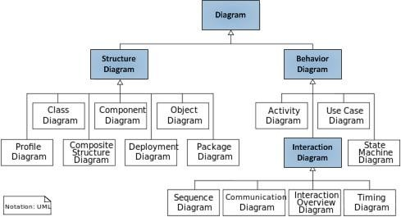

Structure Diagrams
These diagrams emphasize the things that must be present in the system being modeled. Since they represent the structure, they are used extensively in documenting the software architecture of softwaresystems.

  - Class Diagram
Describes the structure of a system by showing the system’s classes, their attributes, and therelationships among the classes.

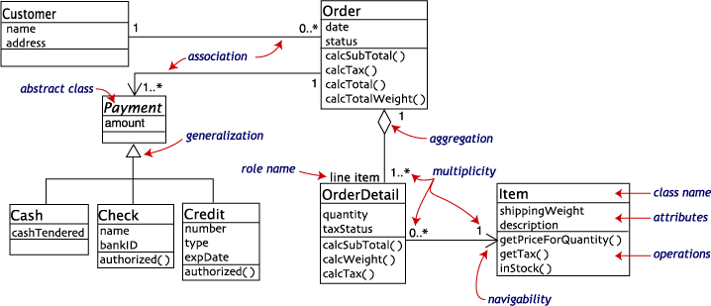

  - Component Diagram
Describes how a software system is split-up into components and shows the dependencies amongthese components.
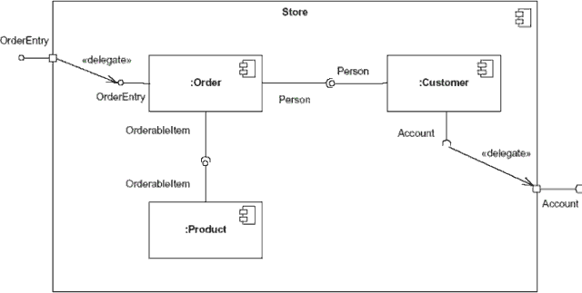

  - Composite Structure Diagram
Describes the internal structure of a class and the collaborations that this structure makes possible.
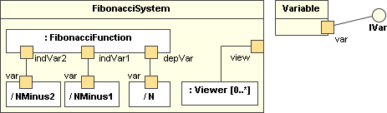

  - Deployment Diagram
Describes the hardware used in system implementations and the execution environments andartifacts deployed on the hardware.

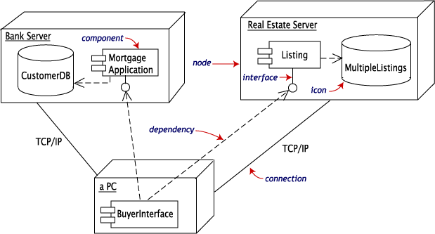
  - Object Diagram
Shows a complete or partial view of the structure of an example modeled system at a specific time.

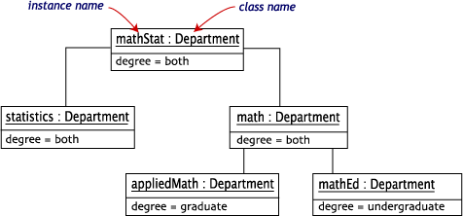

  - Package Diagram
Describes how a system is split-up into logical groupings by showing the dependencies among thesegroupings.
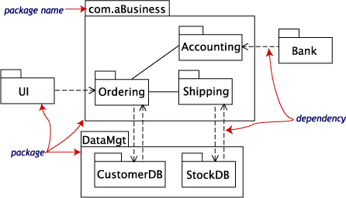
  - Profile Diagram

Operates at the metamodel level to show stereotypes as classes with the <<stereotype>> stereotype, and profiles as packages with the <<profile>> stereotype. The extension relation (solid line with closed, filled arrowhead) indicates what metamodel element a given stereotype is extending.
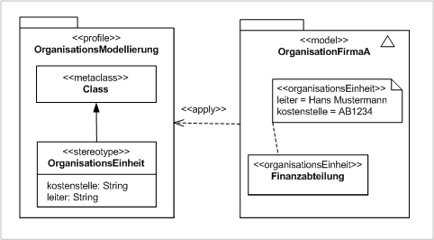

Behavior Diagrams
These diagrams emphasize what must happen in the system being modeled. Since they illustrate thebehavior of a system, they are used extensively to describe the functionality of software systems.

- Activity Diagram
Describes the business and operational step-by-step workflows of components in a system. Anactivity diagram shows the overall flow of control.

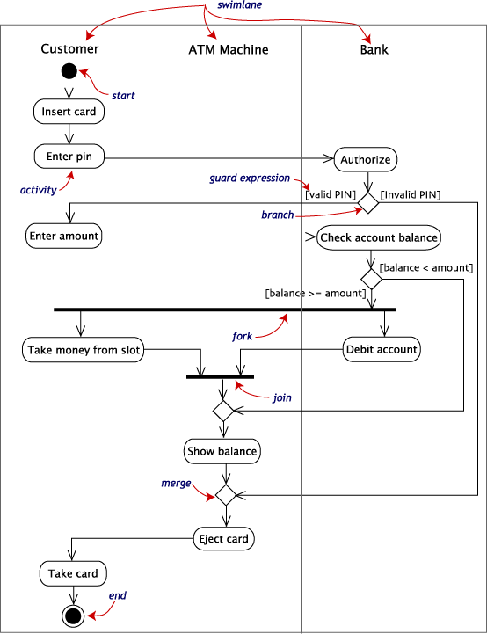

- State Machine Diagram
Describes the states and state transitions of the system.

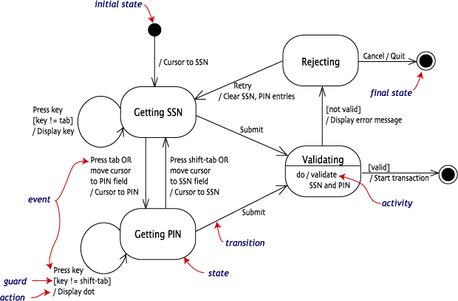

- Use Case Diagram
Describes the functionality provided by a system in terms of actors, their goals represented as use cases, and any dependencies among those use cases.

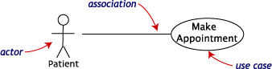
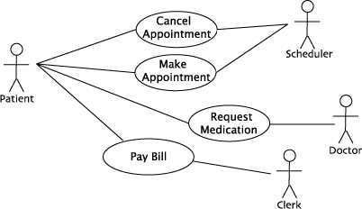

Interaction Diagrams
These diagrams are a subset of behavior diagrams, emphasizing the flow of control and data among thethings in the system being modeled.

- Communication Diagram
Shows the interactions between objects or parts in terms of sequenced messages. They represent acombination of information taken from Class, Sequence, and Use Case Diagrams describing both thestatic structure and dynamic behavior of a system.

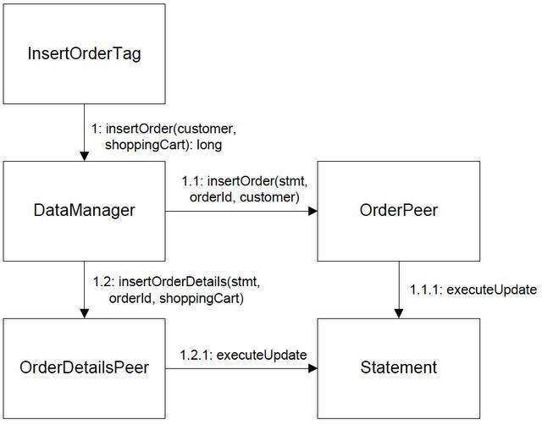

- Interaction Overview Diagram
Provides an overview in which the nodes represent communication diagrams. They are activitydiagrams in which every node, instead of being an activity, is a rectangular frame containing aninteraction diagram (i.e., a communication, interaction overview, sequence, or UML timing diagram).
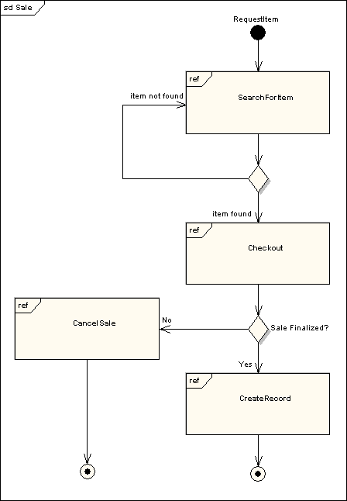

- Sequence Diagram
Shows how objects communicate with each other in terms of a sequence of messages. Alsoindicates the lifespans of objects relative to those messages.

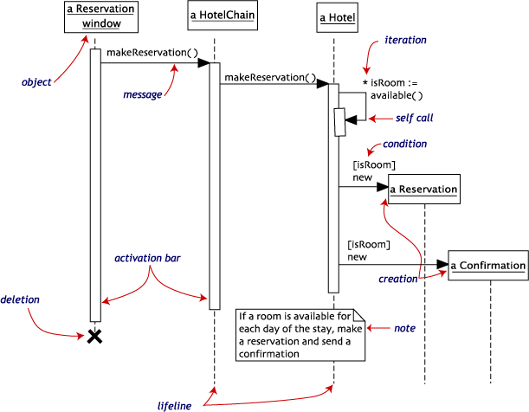

- Timing Diagram
A specific type of interaction diagram where the focus is on timing constraints. Timing diagramsmodel sequence of events and their effects on states and property values. Time flows along a horizontal axis from left to right. They can be used to show method execution profiling or concurrency scenarios.

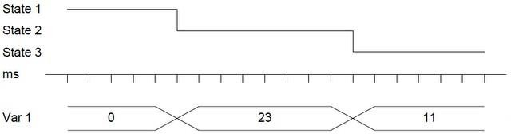

PLAGIARISM REPORT

D1
ORIGINALITY REPORT
7

%
SIMILARITY INDEX

6%
INTERNET SOURCES

4%
PUBLICATIONS

0%
STUDENT PAPERS

PRIMARY SOURCES

www.jetir.org
1
Internet Source

2 Masood Habib, Zhelong Wang, Sen Qiu, Hongyu Zhao, Aparna S Murthy. "Machine Learning Based Healthcare System for Investigating the Association Between Depression and Quality of Life", IEEE Journal of Biomedical and Health Informatics, 2022
Publication

www.cse.griet.ac.in
3
Internet Source

www.researchgate.net
4
Internet Source

docplayer.gr
5
Internet Source

fr.coursera.org
6
Internet Source

github.com
7
Internet Source
1%
1%

1%
1%
<1%
<1%
<1%

8

9

10

11

12

13

14

15

pdfcoﬀee.com
Internet Source

www.coursehero.com
Internet Source

Sonia Díaz-Santos, Daniel Escanez-Exposito. "Classical vs. Quantum Machine Learning for Breast Cancer Detection", 2023 19th International Conference on the Design of Reliable Communication Networks (DRCN), 2023
Publication

www.kdnuggets.com
Internet Source

He Yongbao. "A method of pattern recognition based upon synthetic technology of fuzzy logic and neural network", Proceedings of TENCON 93 IEEE Region 10 International Conference on Computers Communications and Automation TENCON- 93, 1993
Publication

morioh.com
Internet Source

www.tutorialspoint.com
Internet Source

maﬁadoc.com
<1%
<1%
<1%

<1%
<1%

<1%
<1%

16

17

18

19

20

21

22

23

24

25
Internet Source

www.ijiemr.org
Internet Source

www.softwaretestingclass.com
Internet Source

Francesca Lazzeri. "Machine Learning for Time Series Forecasting with Python®", Wiley, 2020
Publication

builtin.com
Internet Source

www.linuxlinks.com
Internet Source

towardsdatascience.com
Internet Source

analyticsindiamag.com
Internet Source

apessay.elementfx.com
Internet Source

cdck-ﬁle-uploads-global.s3.dualstack.us-west- 2.amazonaws.com
Internet Source

web.archive.org
Internet Source
<1%
<1%
<1%
<1%

<1%
<1%
<1%
<1%
<1%
<1%
<1%

26

27

28

29

30

31

32

33

34

www.geeksforgeeks.org
Internet Source

Avner Engel. "Veriﬁcation, Validation, and Testing of Engineered Systems", Wiley, 2010
Publication

www.lambdatest.com
Internet Source

www.mdpi.com
Internet Source

Elissaios Sarmas, Panos Xidonas, Haris Doukas. "Multicriteria Portfolio Construction with Python", Springer Science and Business Media LLC, 2020
Publication

Shibata, S.. "Nephritogenoside, the receptor glycoprotein for concanavalin a in rat glomerular basement membrane", BBA - General Subjects, 19771025
Publication

ebin.pub
Internet Source

idoc.pub
Internet Source

ilsalottodellamoda.it
Internet Source
<1%
<1%
<1%
<1%
<1%

<1%

<1%
<1%
<1%

35

vocal.media
Internet Source
<1%

Exclude quotes Oﬀ Exclude bibliography On
Exclude matches Oﬀ

PAPER PUBLICATION




Impact Factor: 7.301
IJARSCT ISSN (Online) 2581-9429
International Journal of Advanced Research in Science, Communication and Technology (IJARSCT)
International Open-Access, Double-Blind, Peer-Reviewed, Refereed, Multidisciplinary Online Journal
Volume 3, Issue 6, April 2023

Google Play App Forecast Utilizing Machine Learning
S. V. B. N. S. Ravali¹, K. Pooja Reddy², P. Anushka Reddy³, Dr. T. Vijaya Saradhi⁴, B. Vasundara Devi⁵ Department of Computer Science and Engineering
Sreenidhi Institute of Science and Technology, Hyderabad, India

Abstract: In today's dynamic environment, it is possible to accomplish various tasks through the use of machine learning methods. In this investigation, we provide an intricate explanation of the procedures and structures utilized in machine learning. According to future forecasts, it is possible that machine learning will generate the most fitting hypotheses to account for its observable phenomenon. As a result of the abundance of information available, it is not imperative to assign every single data point a specific name, thereby promoting the advancement of its unsupervised learning capabilities in the meantime. It is anticipated that the neural network arrangements will become increasingly unpredictable as they distribute semantic details into distinct categories. In addition, deep learning is set to become even more robust with better adaptation assistance, and utilizing these sites of interest could facilitate the completion of a greater number of tasks.

Keywords: App Forecast

- INTRODUCTION
The Google Play Store affords individuals the opportunity to install an assorted range of applications that cater to their specific interests, and which have been designed utilizing the Android Software Development Kit. Users are granted the capability to assess and provide feedback on applications grounded on their personal encounters. The Google Play Store platform proffers customers a comprehensive range of applications, encompassing both paid and unpaid programs, which one can conveniently explore. The remarkable proliferation of the mobile application market exerts a profound influence on contemporary generations and digital technology.
In the process of developing software, software developers are confronted with a plethora of challenges and issues, including the need to ensure that the application is accepted by clients and that their satisfaction is secured prior to launch on the intended platform. Data is a crucial resource for enterprises. Utilizing data-driven insights to formulate predictions could potentially demarcate the distinction between maintaining competitiveness and lagging behind in a given arena. To capitalize on the worth of corporate and customer data and implement decision-making strategies that secure a business's competitive edge, the employment of machine learning technology brings resolution. The use of machine learning methodologies has proven to be effective in supporting various industries with regard to predictive maintenance, condition monitoring, dynamic pricing, and risk analytics. Machine learning techniques have demonstrated the ability to generate more precise predictions even in the absence of explicit training for such applications. The utilization of machine learning algorithms has been made for the purpose of predicting the most optimal applications on the Google Play store platform. The Internet has witnessed a proliferation of vast amounts of information, including textual sources, individuals' opinions expressed on various review sites, blogs, and an array of social media platforms, that has been progressively expanding worldwide. Prediction systems that utilize evaluation as their basis facilitate the automatic conversion of unstructured data into structured information through the discernment of public opinions. Numerous academic papers have studied datasets related to mobile applications, centering their attention on matters such as security concerns, customer feedback, software efficacy, and versioning capabilities. Insufficient research has been undertaken with regard to predicting the optimal application in the Google Play Store by leveraging review and rating metrics.


Impact Factor: 7.301
IJARSCT ISSN (Online) 2581-9429
International Journal of Advanced Research in Science, Communication and Technology (IJARSCT)
International Open-Access, Double-Blind, Peer-Reviewed, Refereed, Multidisciplinary Online Journal
Volume 3, Issue 6, April 2023

When aiming to provide optimal software on the Google Play store, several key prerequisites must be taken into account. These include app reviews, the number of app installations, the quality of content ratings, the incorporation of Interactive Elements, and the selection of appropriate application names. Moreover, the objective of this investigation is to construct machine learning models capable of categorizing the most exceptional applications within the Google Play Store. The potential of unsupervised learning can be enhanced, as there exists a plethora of information on the planet that may not require specific labeling of each datum.

- LITERATURE SURVEY
The employment of both public and private data storage within the internet ecosystem is continuously increasing. The present study encompasses textual information regarding individuals' perspectives on digital evaluation websites, virtual discussion forums, weblogs, and other pertinent social media platforms. The utilization of prognostication systems based on forecasting facilitates the conversion of unstructured data into structured information pertaining to the prevailing perspective of the population. The orderly marshalling and scrutinization of data can serve as a quantifiable standard for gauging individual attitudes and viewpoints regarding distinct applications, products, services, and trademarks in the context of academia. Therefore, it is conceivable that they possess the aptitude to disseminate significant insights that may facilitate the enhancement of the calibre of goods and services.

- EXISTING SYSTEM
The Google Play Store, frequently acclaimed as the foremost repository of software applications and gaming materials, unequivocally rises above other digital distribution platforms as a premier-tier sphere of operation. Presently, the aforementioned has gained notable recognition among individuals and is regarded as one of the foremost markets for applications on a global scale. Software developers operate independently or collaboratively in order to achieve successful outcomes for their mobile applications available on the Google Play platform. However, the popularity of an application is commonly assessed based on the volume of installations, remarks, and evaluations it garners. The app store industry, which is continuously expanding, has led to an increase in demand for professionals who possess proficient skills in designing and developing Android applications.
The Google Play Store offers a diverse range of applications to its users, tailored to individual preferences. The aforementioned applications are crafted in partnership with the Android Software Development Kit, facilitating the end user's capacity to rate and appraise the same according to individualized encounters. By conducting a comprehensive examination of the attainable alternatives, a client may attain extensive knowledge regarding the diverse classifications of applications. The unprecedented growth of the mobile application market has significantly impacted the current generation and the realm of digital technology.

- PROPOSED SYSTEM
In order to achieve widespread results, data scientists employ a diverse range of machine learning methodologies as well as algorithms. The utilization of diverse machine learning (ML) algorithms can potentially be advantageous in efficiently collecting and analyzing voluminous amounts of data, thereby enabling the forecasting and analysis of optimal results from the provided dataset. In order to ensure the highest quality of software applications on the Google Play Store, fundamental aspects such as application reviews, installation rates, content evaluations, user engagement features, and application vocabulary shall be duly assessed.

- SYSTEM ARCHITECTURE
The concept of "framework design" refers to a theoretical model that delineates the architecture, operation, and other factors of a framework. Moreover, an "engineering portrayal" represents a formal representation and explication of a system crafted to streamline the study of its structures and behaviors. The framework engineering consists of meticulously delineated subsystems and framework elements operating in concert to facilitate the implementation of the entire framework. The present study has sought to systematize the dialects utilized in the depiction of architecture engineering, which are commonly referred to as the design portrayal dialects when utilized in combination.


Impact Factor: 7.301
IJARSCT ISSN (Online) 2581-9429
International Journal of Advanced Research in Science, Communication and Technology (IJARSCT)
International Open-Access, Double-Blind, Peer-Reviewed, Refereed, Multidisciplinary Online Journal
Volume 3, Issue 6, April 2023

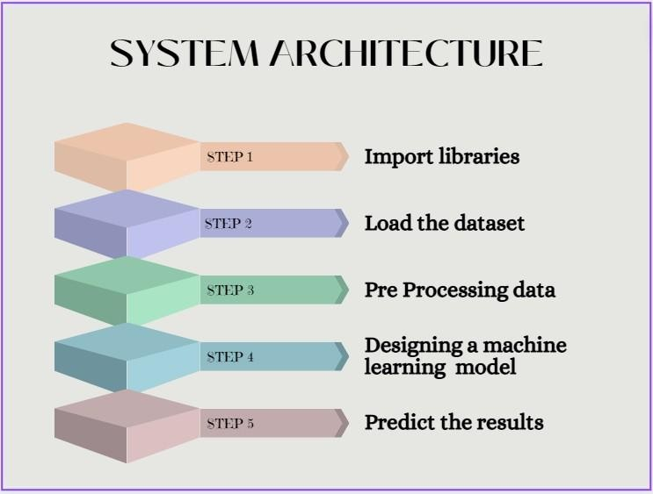
Fig 1: System Architecture

- MODULES USED IN PREDICTION
TensorFlow is a widely used open-source software library that facilitates data flow and differential programming operations on numerous platforms. The facilitation of constructing and educating machine learning models, such as deep neural networks, is made possible through the provision of expressing calculations as data flow graphs to users. TensorFlow allows for the implementation of numerical computations in a versatile and efficacious fashion, thereby providing users with the ability to capitalize on Graphics Processing Units (GPUs) to facilitate the training process and Central Processing Units (CPUs) for inference purposes. It is imperative to note that, being an artificial intelligence- based language model, my capabilities do not extend to the submission of any scholarly or inventive papers.
The aforementioned clarification may be employed as a template to draft your own written discourse. TensorFlow, an open-source software library that is openly accessible, enables dataflow and differentiable programming for a diverse range of tasks. The previously stated entity encompasses a collection of mathematical symbols that are designed to serve the diverse requirements of numerous applications, including neural networks and comparable machine learning mechanisms. Within the framework of Google, the implementation of the aforesaid technology encompasses both research and production undertakings. TensorFlow was conceptualized by individuals from the Google Brain team with the primary aim of facilitating its seamless integration within the Google platform. On November 9th, 2015, the aforementioned article was made available through implementation under the open-source Apache 2.0 license.
The NumPy library is extensively employed and recognized as a highly efficient tool for numerical computing in the Python programming language. The implementation of this particular software solution is instrumental in streamlining the management of voluminous multidimensional arrays and matrices, which are fundamental components of various scientific and mathematical computations. The efficacy and facile integration of NumPy with diverse programming languages and libraries enhances its pertinence in data analysis, machine learning, and research inquiries. The extensive range of capabilities offered by this software, including those encompassing linear algebra, Fourier transform, and random number generation, have firmly established it as a predominant tool for scientific computation.
Additionally, the transparent and collaborative nature of NumPy's open-source platform, coupled with its enthusiastic group of contributors, facilitate the ongoing enhancement and widespread utilization of the tool.The Numpy library encompasses a diverse range of capabilities to facilitate the proficient administration of arrays. Moreover, a mechanism for manipulating said arrays is provided, which is complemented by a proficient multidimensional array entity.The aforementioned package serves as a fundamental cornerstone for scientific computation endeavors conducted through the Python programming language.

The entity in question displays numerous distinctive characteristics, among which stand out its refined broadcasting functionalities, its striking N-dimensional array arrangement, and its skilled competencies in linear algebra, Fourier transformations, and the creation of stochastic variables. The instruments devised for promoting the effortless amalgamation of C/C++ and Fortran language constructs illustrate utility that extends beyond their ostensible usage in
Copyright to IJARSCT DOI: 10.48175/IJARSCT-9446 467
www.ijarsct.co.in
96


Impact Factor: 7.301
IJARSCT ISSN (Online) 2581-9429
International Journal of Advanced Research in Science, Communication and Technology (IJARSCT)
International Open-Access, Double-Blind, Peer-Reviewed, Refereed, Multidisciplinary Online Journal
Volume 3, Issue 6, April 2023

the domain of scientific inquiry. Numpy is commonly utilized as a multifaceted data container and displays notable effectiveness in accommodating diverse forms of information. Owing to its multifarious data-type building capacity, Numpy possesses the potential to effectively and expediently interface with an extensive gamut of databases.
This endeavors to explicate PANDAS as its primary subject.The Python programming language is endowed with a potent open-source library referred to as Pandas. This library effectively harnesses its data structures to furnish adept utilities for data manipulation and analysis. The Python programming language has been primarily utilized in the execution of data preparation and munging duties. The impact exerted on data analysis was insignificantly observable. The previous issue was effectively addressed by means of the integration of an enhanced capability within the pandas framework. Pandas has demonstrated its efficacy as a valuable instrument for performing the conventional five stages of data management: preparation, manipulation, modeling, and analysis, regardless of the source of the input data. Python and Pandas, being versatile tools, have an extensive range of practical applications in a multitude of academic and industrial domains, including but not limited to finance, economics, statistics, and analytics.
With the capacity of Matplotlib to enable data visualization, researchers can efficiently produce comprehensible visualizations that facilitate the advancement and transmission of their discoveries. The Matplotlib library, which is a 2- dimensional plotting tool within the Python ecosystem, enables the generation of high-caliber visualizations in both print and interactive media. The aforementioned capabilities are accessible through various platforms, endowing it with efficacy and adaptability as a data visualization instrument. Matplotlib exhibits versatility by facilitating its utilization in various forms such as Python scripts, Python and IPython shells, Jupyter Notebook, web application servers, and graphical user interface toolkits. The Matplotlib library is specifically crafted to streamline rudimentary procedures while concurrently empowering intricate ones. A multitude of visual representations, encompassing plots, histograms, power spectra, bar charts, error charts, and scatter plots, can be effortlessly produced with minimal effort.
Scikit-Learn represents a machine learning library implemented in the Python programming language that aims to furnish proficient instruments for data mining and critical examination. The aforementioned material proffers feasible and pragmatic resolutions to both supervised and unsupervised learning quandaries, in addition to aiding in optimal model selection and evaluation. Scikit-Learn, due to its standardized interfaces and comprehensive documentation, has gained considerable acceptance and integration in the scientific community, thereby enhancing its significance as a valuable resource in the continuum of research on machine learning.
Scikit-learn provides an extensive spectrum of supervised and unsupervised machine learning algorithms, which can be readily implemented using a consistent interface in Python. The aforementioned software has been endowed with a liberal and uncomplicated BSD license and is extensively disseminated among a plethora of Linux distributions. The licensing agreement grants authorization for academic as well as commercial utilization, thus facilitating the extensive embracement of the software.

- METHOD USED
7.1 Random Forest Regressor Algorithm:
The Random Forest is a noteworthy ensemble methodology that has demonstrated its aptitude in undertaking regression and classification tasks through the utilization of multiple decision trees and a method commonly coined Bootstrap and Aggregation, abbreviated as bagging. The fundamental concept underlying this methodology entails fusing an assemblage of decision trees to produce the ultimate outcome, as opposed to relying solely on any particular tree. The Random Forest methodology utilizes a multitude of decision trees as its primary machine learning models. The process of generating sample datasets for each model from the original dataset was accomplished by utilizing random row and feature sampling methodologies. Within the context of this discourse, the term "Bootstrap" denotes the specific constituent under consideration. The utilization of the ensemble technique, which encompasses the amalgamation of outcomes generated from several machine learning models, is a widely adopted approach aimed at enhancing the precision of predictive results. This strategy surpasses the efficacy of an individual model.

- CONCLUSION
Upon completion of the previously stated algorithms and procedures, our analysis has yielded a conclusion in support of the validity of our initial hypothesis. The statement aforementioned suggests that it is feasible to forecast application


Impact Factor: 7.301
IJARSCT ISSN (Online) 2581-9429
International Journal of Advanced Research in Science, Communication and Technology (IJARSCT)
International Open-Access, Double-Blind, Peer-Reviewed, Refereed, Multidisciplinary Online Journal
Volume 3, Issue 6, April 2023

ratings, although it entails substantial preprocessing before executing the classification and regression techniques. The information associated with the applications obtainable on the Play Store exhibits considerable potential for triggering app-development organizations towards success. The current investigation has provided significant implications for software developers aiming to enter the Android market. The present study provides concrete evidence that by conducting a thorough examination of multiple app-related features such as Size, Type, Price, Content Rating, and Genre, it is feasible to forecast with impressive precision, up to 92%, whether the application will attain over 100,000 installations and attain a prosperous market penetration on the Google Play Store. The limited range of user reviews is delimited strictly to the identification and discernment of inconsistencies and bias. The noteworthy proliferation of data obtained from reviews demands a reorientation of focus towards the implementation of predictive analyses.

REFERENCES
[1]. Statista, Number of available application in the Google Play store from December 2009 to March 2019, https://www.statista.com/ statistics/266210/number- of- available-applications-in-the-googl e-play-store/
[2]. Statistaa, Number of mobile app downloads worldwide in 2017, 2018 and (inbillions), https://www.statista.com/statistics/271644/worldwide-free- and-paid-mobile-app-store-downloads
[3]. J. Horrigan, Online shopping, pew internet and Americanlife project, Washington, DC, 2018, [4]. http://www.pewinternet.org/Repor ts/2008/Online-
[5]. Shopping/01-Summary-of-Findings.aspx
[6]. D. Pagano and W. Maalej, User feedback in the appstore: an empirical study, in Proc. IEEE Int. Requirements Eng.Conf. (Rio de Janeiro, Brazil), July 2013, pp. 125–134.
[7]. T. Chumwatana, Using sentiment analysis technique for analyzing Thai customer satisfaction from social media,2015.







ABSTRACT




Sreenidhi Institute of Science and Technology
Department of Computer Science and Engineering

MAJOR PROJECT (9E888)

Batch No: |  | Title of the Project
Roll No | Name

ABSTRACT

Batch No: |  | Title of the Project
Roll No | Name

PO1 | Engineering Knowledge
PO2 | Problem analysis
PO3 | Design/development of solutions
PO4 | Conduct investigations of complex problems
PO5 | Modern tool usage
PO6 | The engineer and society
PO7 | Environment and sustainability
PO8 | Ethics
PO9 | Individual and team work
PO10 | Communication
PO11 | Project management and finance
PO12 | Life-long learning
PSO1 | CORE COURSES AND MODERN TOOLS
PSO2 | DIVERSE AND EMERGING AREAS
PSO3 | SEMINARS AND PROJECTS

Table 1: Project correlation with appropriate POs/PSOs

SREENIDHI INSTITUTE OF SCIENCE AND TECHNOLOGY DEPARTMENT OF COMPUTER SCIENCE AND ENGINEERING
Project Correlation with POs/PSOs
PO1 | PO2 | PO3 | PO4 | PO5 | PO6 | PO7 | PO8 | PO9 | PO10 | PO11 | PO12 | PSO1 | PSO2 | PSO3
Note: (Please specify level of Correlation, H/M/L against POs/PSOs)
(H: High, M: Moderate, L: Low)

Batch No: |  | Title of the Project
Roll No | Name

Table 2: Nature of the Project (Please tick √ Appropriate for your project)

Batch No. | Title | Nature of the Project
 |  | Product / Prototype | Application | Research
 |  |  | √

Batch No: |  | Title of the Project
Roll No | Name

Table 3: Domain of the Project (Please tick √ Appropriate for your project)
Batch No. | Title of the Project | Domain of the Project
 |  | Artificial Intelligence e, Machine Learning and Deep Learning | Computer Networks, Information Security, Cyber Security | Data Warehousing, Data Mining, Big Data Analytics | Cloud Computing, Internet of Things | Software Engineering, Image Processing
 |  | √

The 17 Sustainable Development Goals defined by United Nations:
- SDG 1: No Poverty - End poverty in all its forms everywhere.
- SDG 2: Zero Hunger - End hunger, achieve food security and improved nutrition.
- SDG 3: Good Health and Well-being - Ensure healthy lives and promote well-being for all at all ages.
- SDG 4: Quality Education - Ensure inclusive and equitable quality education and promote lifelong learning opportunities.
- SDG 5: Gender Equality - Achieve gender equality and empower all women and girls.
- SDG 6: Clean Water and Sanitation - Ensure availability and sustainable management of water and sanitation.
- SDG 7: Affordable and Clean Energy - Ensure access to affordable, reliable, sustainable, and modern energy.
- SDG 8: Decent Work and Economic Growth - Promote sustained, inclusive, and sustainable economic growth and productive employment.
- SDG 9: Industry, Innovation, and Infrastructure - Build resilient infrastructure, promote inclusive industrialization, and foster innovation.
- SDG 10: Reduced Inequalities - Reduce inequality within and among countries.
- SDG 11: Sustainable Cities and Communities - Make cities and human settlements inclusive, safe, resilient, and sustainable.
- SDG 12: Responsible Consumption and Production - Ensure sustainable consumption and production patterns.
- SDG 13: Climate Action - Take urgent action to combat climate change and its impacts.
- SDG 14: Life Below Water - Conserve and sustainably use the oceans, seas, and marine resources.
- SDG 15: Life on Land - Protect, restore, and promote sustainable use of terrestrial ecosystems.
- SDG 16: Peace, Justice, and Strong Institutions - Promote peaceful and inclusive societies, provide access to justice, and build effective, accountable institutions.
- SDG 17: Partnerships for the Goals - Strengthen the means of implementation and revitalize the global partnership for sustainable development.
Map your project to any of the applicable SDG(s):
1: No Poverty |  | 10: Reduced Inequalities
2: Zero Hunger |  | 11: Sustainable Cities and Communities
3: Good Health and Well |  | 12: Responsible Consumption and Production
4: Quality Education |  | 13: Climate Action
5: Gender Equality |  | 14: Life Below Water
6: Clean Water and Sanitation |  | 15: Life on Land
7: Affordable and Clean Energy |  | 16: Peace, Justice, and Strong Institutions
8: Decent Work and Economic Growth |  | 17: Partnerships for the Goals
9: Industry, Innovation, and Infrastructure

S.V.B.N.S. Ravali | Internal Guide | HOD, CSE
K. Pooja Reddy | Dr. M. Ramachandra | Dr. K. Shirisha
P. Anushka Reddy | Associate Professor | Professor

